DEDICATION

ACKNOWLEDGEMENT

I would like to thank my esteemed supervisor Ms. Prachi for her invaluable supervision, support and guidance. I would like to express gratitude to her for her treasured support which was really influential in shaping my experiment methods and critiquing my results. I also would like to thank DR. Manoj Jayabalan from Liverpool John Moores University for his continues guidance through the weekly sessions.

I would also like to thank my wife Shalini Moondra, daughter Saanjh Moondra and son Rachit Moondra for their encouragement to let me pursue my academic goals and also ensuring that I stay focussed. Finally, I would like to thank my family and friends for supporting in every way possible which enabled me to complete my research.

Thank you

Ratish Moondra

ABSTRACT

The stock market, critical for both global and national economies, has experienced significant growth and volatility across the world. It exerts significance influence on economic and decision-making ability of various stakeholder e.g. individual investors, financial analysts, traders, and market practitioners. Consequently, stakeholders are quite keen on achieving accurate prediction.

Despite great advancements in AI and ML, predicting future stock prices remains challenging but advantageous task at the same time and an area of active research. This study aims to integrate Deep Reinforcement Learning (DRL) and Sentiment Analysis (SA) to create a robust investment decision system. By utilizing NLP techniques and establishing corelation with historical price data, the framework aims to extract textual sentiments and improve investment decisions. This research contributes to enhancing Stock Market Prediction (SMP) methodologies and providing insights for navigating through the modern financial markets. From modelling perspective, the proposed research methodology will infuse Sentiment Analysis (to extract sentiment score i.e. positive, negative or neutral), combine it with Deep neural network (i.e. Long Short-Term Memory) & Unsupervised learning technique (Reinforcement Learning) to understand the hidden data patterns & corelations; thereby maximizing the reward function to help investor makes a right decision and improve profitability and reduce possible losses.

LIST OF TABLES

Table 3.1: Stock Price Prediction - LSTM Pros and Cons 30

Table 3.2: RL + LSTM Approach Pros and Cons 31

Table 3.3: Sentiment Analysis - VADER Pros and Cons 32

Table 3.4: Sentiment Analysis - SentiWordNet Pros and Cons 33

Table 3.5: Sentiment Analysis - Deep Neural Network (DNNs) Pros and Cons 33

Table 3.6: Stock ticker selection 35

Table 3.7: Stock Price Data 36

Table 3.8: StockTwits Tweets Data 37

Table 4.1: Data Selection Criteria 44

Table 4.2: Price statistics at a glance (NEEDS WORK Stock wise count..) 45

Table 4.3: Sentiment Statistics 46

Table 4.4:LSTM Model parameters description 57

Table 4.5: LSTM Predicted Close Prices 61

Table 4.6: VADER Model parameters description 62

Table A.1: Price Data for Stock Market Prediction 98

Table A.2: Tweets or Media Article Data Description 98

Table A.3: Risk and Contingency Plan 105

LIST OF FIGURES

Figure 3.1: High-level Flowchart for Research Approach 29

Figure 3.2: LSTM logical architecture 30

Figure 3.3: LSTM + RL architecture 31

Figure 4.1: Stocks Statistics 45

Figure 4.2: Price Trend – Close and Open 47

Figure 4.3: Close price outlier detection 47

Figure 4.9: Price Distribution 49

Figure 4.10: Daily price movement 49

Figure 4.11: Heatmap for price correlation 50

Figure 4.4: Sentiment count aggregate 51

Figure 4.5: Sentiment count detailed 51

Figure 4.6: Word count aggregate 52

Figure 4.7: Word count detailed 52

Figure 4.8: Tweet volume over time 53

Figure 4.12: # of tweets & stock price activity 54

Figure 4.13: Sentiment score vs Price change 55

Figure 4.14: Physical model architecture 57

Figure 4.15: Hyperparameter Tuning for LSTM Model 60

Figure 4.16: Physical LSTM model architecture 64

Figure 4.17: RL Model Architecture 65

Figure 4.18: Buy signal reward function 66

Figure 4.19: Sell signal reward function 67

Figure 4.20:Hold signal reward function 67

Figure A.1: Sentiment Analysis 100

Figure A.2: Unsupervised Learning (Reinforcement Learning) 101

Figure A.3: LSTM Network (in conjunction with RL architecture in Figure 2) 101

Figure A.4: Research Project Plan 104

LIST OF ABBREVIATIONS

AI Artificial Intelligence

ATS Automated Trading System

CNN Convolutional Neural Network

CR Cumulative Return

DRL Deep Reinforcement Learning

FA Fundamental Analysis

ISI Investment Sentiment Index

LSTM Long Short-Term Memory

MAS Multi Agent System

MER Maximum Error Rate

ML Machine Learning

NLP Natural Language Processing

RNN Recurrent Neural Network

SA Sentiment Analysis

SMP Stock Market Prediction

SVM Support Vector Machine

TA Technical Analysis

VADER Valence Aware Dictionary and sEntiment Reasoner

DEDICATION I

ACKNOWLEDGEMENT II

ABSTRACT III

LIST OF TABLES IV

LIST OF FIGURES V

LIST OF ABBREVIATIONS VI

CHAPTER 1: INTRODUCTION 1

1.1. Background of the Study 1

1.2. Problem Statement 2

1.3. Aim and Objectives 3

1.4. Research Questions 3

1.5. Scope of the Study 4

1.6. Significance of the Study 4

1.7. Structure of the Study 5

CHAPTER 2: LITERATURE REVIEW 7

2.1. Machine Learning in Quantitative Finance 7

2.2. Exploring Advancements in Stock Price Prediction 9

2.3. Deep Learning 9

2.4. Reinforcement Learning 10

2.5. Deep Reinforcement Learning 12

2.6. Foundations of Sentiment Analysis in Finance 15

2.7. Researches related to Sentiment Analysis 16

2.8. Combination of SA + Machine Learning Model 18

2.9. Convergence of SA + Deep Learning 19

2.10. Transfer Learning 20

2.11. Multi-Agent Systems and Collective Intelligence Learning 22

2.12. Automated Stock Trading Systems 24

2.13. Discussion 25

2.14. Summary 25

CHAPTER 3: RESEARCH METHODOLOGY 28

3.1. Introduction 28

3.2. Research Approach 28

3.3. Algorithm Selection Rational 29

3.4. Data Collection 35

3.5. Data Source Description 36

3.6. Feature Engineering 38

3.7. Pre-processing 39

3.8. Visual Analytics 41

3.9. Model Evaluation 42

Summary 42

CHAPTER 4: ANALYSIS 44

4.1. Introduction 44

4.2. Data Selection 44

4.3. Data Preprocessing 46

4.4. Feature Engineering 48

4.5. Exploratory Data Analysis (EDA) 48

4.6. Model Building and Tuning 55

4.7. Summary 68

CHAPTER 5: RESULTS AND DISCUSSION 69

5.1. Introduction 69

5.2. Model Drift Results 70

5.3. Model Interpretability 77

5.4. Sensitivity Analysis 78

5.5. Results and Analysis 78

5.6. Research Questions 78

5.7. Detailed Analysis of Results 79

5.8. Comparative Analysis 79

5.9. Case Studies or Examples 80

5.10. Sensitivity Analysis 80

5.11. Summary 80

CHAPTER 6: CONCLUSIONS AND RECOMMENDATIONS 81

6.1. Introduction 81

6.2. Discussion & Conclusions 81

6.3. Contribution to knowledge 83

6.4. Future recommendation 83

REFERENCES 85

APPENDIX-A: RESEARCH PROPOSAL 89

# INTRODUCTION

## Background of the Study

Stock markets are an important pillar for Global and National businesses & economy. They have experienced an unprecedented growth increasingly lucrative but fairly complex and high-risk space due to its volatile nature or agility. Anticipating future stock prices, termed Stock Market Prediction, remains an area of immense interest for academics, researchers, and economists alike. Recent advancements in the field of Sentiment Analysis, Artificial Intelligence, and Machine Learning have introduced novel perspectives into decision-making processes for investors. Researcher have tried to use a range of traditional algo such as Random Forests, Timeseries, Support vector machine algorithms to latest deep neural network-based algorithms. Most recently (Zou et al., 2024) used Neural Networks such as cascaded LSTM framework at deciphering patterns from historical data and focussed on increasing Cumulative Return (CR), MER (maximum earning rate) and Average profitability thereby improving range from 5% to 52% depending on a combination of metric and respective stock index.

However, the challenge persists in how predictive/deep learning models react or adapt to unexpected/unforeseen market events influenced by different factors such as macro or micro economic tendencies, sovereign GDP/economy, market subtleties, companies’ growth prospects, consumer prices, central bank policies, and industry-specific nuances. Sahu (Sahu et al., 2023) described a plethora of algorithms and their families being applied in this space and keep the researchers most current. He also underlined the fact that DRL agents, combining price prediction and trading signal, have been deployed for automated trading systems. The fusion of diverse data points such as Technical Analysis (TA) (i.e. a methodology to predict stock movement using historical prices (open, close, high, low), volume), and Sentiment Analysis (SA) for extracting the mood of the market, presents a promising avenue for employing greater influence on investment decisions.

This research endeavours to amalgamate DRL and SA to formulate a robust decision-making system. DRL, processing multidimensional data spaces to generate actions without supervision, addresses challenges posed by incomplete information or various external economic factors. The proposed contributions include:

* Leveraging NLP for preprocessing texts such as tweets to extract sentiments
* Historical price data extraction for various stocks
* Utilization of LSTM with Reinforcement Learning for pattern/corelation in stock data.

## Problem Statement

In the realm of stock market prediction (SMP), despite advancements in Artificial Intelligence (AI) and Machine Learning (ML), accurately forecasting future stock prices remains a significant challenge. The unpredictability of market dynamics, influenced by a myriad of factors including macro and micro-economic trends, poses a formidable obstacle to traditional predictive models. Consequently, there is a pressing need for innovative methodologies that can effectively integrate diverse data sources and adapt to dynamic market conditions. This research aims to address this challenge by integrating Deep Reinforcement Learning (DRL) and Sentiment Analysis (SA) techniques to develop a robust investment decision system. By leveraging Natural Language Processing (NLP) for sentiment extraction from textual data such as tweets, and combining it with historical price data, the proposed framework seeks to uncover hidden patterns and correlations using Long Short-Term Memory (LSTM) networks and Reinforcement Learning algorithms. The ultimate goal is to empower investors with actionable insights that enhance profitability and mitigate risks in modern financial markets

## Aim and Objectives

The primary aim is to develop a novel model for predicting market moves based on sentiment analysis using NLP and DRL techniques.

Objectives:

* To Analyse existing SA techniques and DRL algorithms applicable to financial markets.
* To Propose an integrated framework that combines NLP for SA and DRL for decision-making in stock trading.
* To Capture and preprocess textual data from social media for sentiment analysis.
* To Evaluate effectiveness (accuracy) of the model in predicting market moves and capturing sentiment-driven fluctuations in stock prices.
* To Interpret patterns and correlations discovered by the model in the stock market dataset.

## Research Questions

Most important question to understand is if fusion of NLP and DRL effectively predict market moves, thereby generating an informed action/decision.

This research aims to address following questions:

1. How can SA be leveraged to extract valuable insights from diverse text sources?
2. How can DRL algorithms be integrated with sentiment analysis to develop decision-making framework for stock trading?
3. To what extent does the fusion of NLP and DRL improve the accuracy of predicting market moves?

## Scope of the Study

### Scope

The study will be based on data available in public domain (say price data via yahoo finance or tweets form Stock Twits, X i.e. twitter). No external survey or questionnaire activity will be conducted. The study will use EDA and effectiveness of model developed for prediction. The study will also analyse the performance of the model in relation to sentiment captured and impact on the trading decision. The study is also focused in exploring the DRL (LSTM+RL) with Sentiments Analysis and how this combined model performs which help the investor improve decision making and reduce possible losses.

### Limitation

It's important to acknowledge the limitations of the study, which may include constraints on data availability, computational resources, and the simplifying assumptions made in the model. These limitations will be carefully considered and discussed in the research findings.

While the primary focus of the study is on predicting market moves based on sentiment analysis, there are opportunities for future research to explore additional aspects such as alternative data sources, refining the RL model, and extending the application of these techniques to other financial markets or asset classes.

In summary, the scope of this study encompasses the development and evaluation of a predictive model for sentiment-based stock market analysis using NLP and DRL techniques, with a focus on understanding the relationship between sentiment and market direction.

## Significance of the Study

One of the key challenges in stock market has been to accurately predict the stock prices because it can cause significant losses. A lot of modelling work has been carried out in the past; however, a wider adoption is yet to be seen. This study will be integrating NLP and DRL techniques, and contributes to explore methods for extracting insights from texts and combine them with historical price data for better price prediction.

Another aspect to look at it is the development of a novel predictive model that combines SA with DRL introduces a new approach to stock market forecasting by maximising the associated reward function.

The insights gained from this research will have practical implications for investors, financial analysts, and market practitioners. Accurately predict market moves based on sentiment analysis (& its impact on price movement) can affect investment decisions, improve trading strategies, and mitigate risks specially in volatile market conditions.

The fusion of NLP and DRL techniques represents a significant technological innovation in the field of financial analysis. By harnessing the power of ML and NLP, this research pushes the boundaries of computational finance and opens new avenues for exploring the complex dynamics of financial markets.

## Structure of the Study

CHAPTER 1 sets the stage by providing a comprehensive overview of the research landscape in stock market prediction. Section 1.1 explores historical context and emphasizes the importance of forecasting in dynamic financial markets. Section 1.2 articulates the problem statement, outlining challenges in predicting stock prices amidst market volatility. Section 1.3 clarifies research objectives, detailing goals to be achieved. Section 1.4 formulates research questions to guide the investigative process. Section 1.5 defines the study's scope, delineating boundaries and parameters. Section 1.6 discusses potential constraints and challenges impacting study outcomes.

CHAPTER 2 undertakes a comprehensive literature review, systematically exploring existing knowledge and research findings pertinent to the study. Section 2.1 introduces machine learning in quantitative finance, while Sections 2.2 and 2.3 delve into advancements in stock price prediction techniques, focusing on the evolution of deep learning and reinforcement learning methodologies. Subsequent sections, 2.4 and 2.5, examine the intricacies of ensemble/hybrid models and artificial neural networks. Sections 2.6 and 2.7 present research in Sentiment Analysis, and Sections 2.8 and 2.9 review hybrids of Sentiment Analysis with machine learning or neural networks, synthesizing key insights from prior studies. Lastly, Section 2.10 onwards discusses advancements in transfer learning, Multi-Agent Systems (MAS), and Automated Trading Systems (ATS).

CHAPTER 3 elaborates on the research methodology employed in the thesis, detailing the systematic approach to address research questions and achieve objectives. Section 3.1 provides an overview of the methodological framework. Section 3.2 outlines the research approach, covering data collection, preprocessing, analysis, and interpretation steps. Section 3.3 explains rational for Algorithm selection. Section 3.4 and 3.5 describes the dataset used, its composition, structure, and relevance. Section 3.6 discusses data preprocessing techniques, focusing on cleaning, transformation, and standardization. Section 3.7 touches upon exploratory data analysis (EDA) steps to understand dataset characteristics. Section 3.8 covers hyperparameter tuning methods for optimizing model performance and evaluation criteria to assess model performance and validate findings.

CHAPTER 4 unfolds the analysis of the research methodology, providing a detailed examination of the data, models, and techniques employed. Section 4.1 offers an overview of the analytical framework. In Section 4.2, the dataset used for analysis is described, including its characteristics and relevance to research objectives. Section 4.3, 4.4 and 4.5 details the analysis, covering data preprocessing, exploratory data analysis, and model selection. Similarly, Section 4.6 lays the ground for the Model development and hyper parameter tuning, exploring the performance of various modelling approaches over time. Section 4.7 draws conclusions drawn from the analysis, synthesizing key findings and insights from the Analysis.

CHAPTER 5 presents the results and discussion of the study, offering insights into the findings and their implications for research objectives. Section 5.1 provides an overview of model results for the first year of data analysis, highlighting key findings and performance metrics. In Section 5.2, model drift analysis results are discussed, providing insights into the stability and robustness of predictive models over time. Section 5.3 addresses research questions outlined in the study, offering detailed responses based on the analysis. Section 5.4 discusses the resources utilized, including hardware, software, and data sources. Finally, Section 5.5 synthesizes the results and their implications for research objectives, highlighting key findings and their significance within the broader research context.

CHAPTER 6 concludes the thesis, providing a summary of key findings, implications, and recommendations for future research. Section 6.1 introduces the conclusions chapter, offering an overview of key themes and findings discussed. In Section 6.2, conclusions drawn from the study are synthesized, highlighting key insights and implications gleaned from research findings. Section 6.3 discusses the study's contribution to existing knowledge and its implications for theory, practice, and policy. Finally, Section 6.4 offers recommendations for future research, identifying areas for further investigation and potential avenues for expanding upon the current study.

# LITERATURE REVIEW

In the current rapidly evolving landscape of financial markets, accurate prediction of stock prices and understanding market trends is crucial for investors and financial analysts alike. Traditional quantitative models often struggle to capture the complexities of human behaviour and the influence of news and social media on market dynamics. As a result, there has been increasing interest in alternative data sources and advanced analytical techniques such as sentiment analysis and reinforcement learning.

Sentiment analysis, which involves extracting subjective information from textual data, provides valuable insights into investor emotions and opinions. (Medeiros & Borges, 2020) developed a methodology for sentiment analysis in tweets related to the Brazilian stock market. Their approach included preprocessing techniques and dimensionality reduction methods, resulting in satisfactory performance in sentiment classification and revealing interesting relationships among topics and clusters through visual analysis.

Reinforcement learning, on the other hand, offers a framework for learning optimal decision-making strategies through interaction with the environment. Deep reinforcement learning (DRL) algorithms have gained popularity in algorithmic trading, combining price prediction with trading signal production. Researchers are increasingly integrating sentiment analysis with reinforcement learning techniques to develop more accurate and robust models for predicting stock prices and optimizing trading strategies.

The integration of natural language processing (NLP) and deep reinforcement learning techniques in stock market analysis has emerged as a promising approach. This literature review aims to provide a comprehensive understanding of the methodologies, algorithms, and approaches employed in this field. By categorically outlining the diverse landscape of research, this review identifies potential areas for future exploration and highlights the potential of these innovative techniques in revolutionizing stock price prediction and financial modelling.



## Machine Learning in Quantitative Finance

In recent years, the use of machine learning techniques in quantitative finance has gained significant traction, as they offer effective solutions for predicting market behaviour. A comprehensive overview of these techniques was provided in a paper titled "An Overview of Machine Learning, Deep Learning, and Reinforcement Learning-Based Techniques in Quantitative Finance: Recent Progress and Challenges" by (Sahu et al., 2023). Published in the journal Applied Sciences, the paper extensively examined the application of machine learning, deep learning, reinforcement learning, and deep reinforcement learning in quantitative finance.

The authors emphasized the challenges associated with forecasting stock market behaviour, which has garnered considerable interest among economists and computer scientists alike. The paper reviewed a range of techniques, from traditional linear models to advanced machine learning algorithms, that have been employed in the creation of predictive models for financial markets. Of particular note was the role of machine learning algorithms in extracting high-level patterns from financial market data, enabling more effective anticipation and evaluation of stock and foreign exchange markets.

Furthermore, the paper highlighted the growing adoption of deep learning models by investors looking to leverage artificial intelligence for market analysis. The authors also discussed the emergence of deep reinforcement learning algorithms in algorithmic trading, which have shown promise in the development of automated trading systems or strategies by incorporating price prediction and trading signal generation.

The primary objective of the paper was to provide an up-to-date overview of the landscape of machine learning techniques in quantitative finance and the stock market. By synthesizing existing research and identifying potential future research directions, the paper serves as a valuable resource for researchers and practitioners interested in utilizing machine learning for financial modelling and analysis.

(Dumiter et al., 2023) delved into the intricate relationship between sentiment indices, technical analysis, and the stock market by highlighting the significance of behavioural economics in understanding market dynamics and the role of sentiment in shaping investor decisions. The research aimed to explore the correlation between sentiment indices, market performance, and the macroeconomic environment. It employed both qualitative and quantitative methodologies, including econometric modelling and graphical analysis, to investigate these connections. Key findings suggest a strong correlation between sentiment indices, technical analysis, and stock market movements, particularly in the US market. The study emphasizes the need to consider sentiment dynamics and technical analysis in investment strategies. However, the research acknowledged limitations such as the narrow focus on a single country, the exclusive use of certain sentiment indices, and the need for further advancements in methodology. In conclusion, the study underscored the importance of integrating sentiment analysis and technical analysis for a comprehensive understanding of stock market behaviour. It provided valuable insights for investors and researchers alike, despite the acknowledged limitations.

## Exploring Advancements in Stock Price Prediction

The task of predicting stock prices remains a significant obstacle in the field of quantitative finance, prompting continual advancements and improvements in modelling methods to enhance the accuracy of forecasts. One promising avenue that has gained prominence is the use of deep learning models, which rely on technologies like Long Short-Term Memory (LSTM) networks, Convolutional Neural Networks (CNNs), and transformer-based architectures. These models excel in analysing time-series data and incorporating sentiment features extracted from social media, and they have displayed varying levels of success in their ability to predict stock prices.

(Tao, 2023) conducted a study titled "Predicting BMW Stock Price Based on Linear Regression, LSTM, and Random Forest Regression," focusing on stock price prediction for BMW, a significant aspect of a country's economy. The author aimed to construct reliable models for predicting BMW's stock price by analysing previous days' stock prices. The study employed three models: Multiple Linear Regression, LSTM, and Random Forest Regression. Utilizing five years of BMW stock price data from Kaggle, the author performed data analysis and modelling, employing various graphical methods to explore the data. The study meticulously checked and demonstrated the feasibility and precision of each model, concluding that the Multiple Linear Regression model exhibited the highest accuracy and lowest mean squared error compared to LSTM and Random Forest Regression models. These findings offer insights into guiding further exploration of BMW stock price prediction.

## Deep Learning

(Lawi et al., 2022) explored the implementation of Long Short-Term Memory (LSTM) and Gated Recurrent Units (GRU) on grouped time-series data for accurate stock price prediction in their paper titled "Implementation of Long Short-Term Memory and Gated Recurrent Units on grouped time-series data to predict stock prices accurately." The authors highlighted the dynamic nature of stock price patterns in the capital market and the necessity for accurate data modelling to forecast stock prices with low error rates. They noted the potential of Deep Learning models, particularly LSTM and GRU algorithms, for accurate stock price prediction using time-series data. However, they observed that previous studies on LSTM/GRU implementation had not consistently demonstrated convincing performance results. To address this, the authors proposed eight new architectural models for stock price forecasting by identifying joint movement patterns in the stock market. These models combined LSTM and GRU with four neural network block architectures. The proposed architectural models were evaluated using three accuracy measures: Mean Absolute Percentage Error (MAPE), Root Mean Squared Percentage Error (RMSPE), and Rooted Mean Dimensional Percentage Error (RMDPE), representing lower accuracy, true accuracy, and higher accuracy, respectively, in model usage.

(Kang et al., 2022) proposed a hybrid deep learning model for cryptocurrency price prediction in their study titled "Cryptocurrency Price Prediction with Convolutional Neural Network and Stacked Gated Recurrent Unit." The authors emphasized the importance of accurate price prediction for optimizing cryptocurrency investments, considering virtual currencies as highly profitable assets. Given the time series nature of price prediction tasks, they introduced a hybrid model, termed 1-dimensional convolutional neural network and stacked gated recurrent unit (1DCNN-GRU). This hybrid model integrates a 1-dimensional convolutional neural network to encode cryptocurrency price data into a high-level discriminative representation, followed by a stacked gated recurrent unit to capture long-range dependencies of the representation. The proposed 1DCNN-GRU model was evaluated on three different cryptocurrency datasets, including Bitcoin, Ethereum, and Ripple. Experimental results showcased the superior performance of the proposed model, with the lowest Root Mean Squared Error (RMSE) values of 43.933 on the Bitcoin dataset, 3.511 on the Ethereum dataset, and 0.00128 on the Ripple dataset, outperforming existing methods.

## Reinforcement Learning

Reinforcement learning (RL) offers a framework for learning optimal decision-making policies in dynamic and uncertain environments, making it well-suited for financial trading applications. RL algorithms learn by interacting with the environment and receiving feedback in the form of rewards, allowing traders to adapt to changing market conditions and optimize trading strategies over time. Recent research has explored various RL techniques, including dynamic ensemble models, multi-agent systems, and transaction-aware RL, demonstrating their effectiveness in automated stock trading and portfolio optimization.

The application of reinforcement learning in trading encompasses a wide range of strategies, from single-agent algorithms for automated trading to multi-agent systems for portfolio optimization. Offline RL techniques enable agents to learn from historical data without direct interaction with the market, while online RL algorithms adapt in real-time to changing market conditions. Recent advances in RL have facilitated the development of sophisticated trading systems capable of navigating complex decision spaces and optimizing trading performance across diverse financial instruments.

The adoption of reinforcement learning techniques in finance marked a paradigm shift in algorithmic trading strategies. Reinforcement learning offers a principled framework for learning optimal decision-making policies through trial and error. Early studies focused on developing reinforcement learning algorithms capable of optimizing trading strategies based on reward signals derived from historical market data ((Lin et al., 2023) , (Lee et al., 2023). These algorithms gradually evolved from basic Q-learning approaches to more sophisticated deep reinforcement learning models that could handle high-dimensional state and action spaces ( (Zhang & Lei, 2022) , (Yousefi, 2022)).

(Hambly et al., 2021) conducted a comprehensive survey titled "Recent Advances in Reinforcement Learning in Finance," which discussed the evolving landscape of reinforcement learning (RL) approaches in the finance industry. The authors highlighted the transformative impact of the increasing volume of financial data on data processing and analysis techniques, leading to new theoretical and computational challenges. They emphasized the advantage of RL over classical stochastic control theory and other analytical approaches, particularly in making optimal decisions in complex financial environments with minimal model assumptions. The survey provided an overview of RL concepts, including Markov decision processes, and introduced various algorithms, focusing on value-based and policy-based methods that do not heavily rely on model assumptions. Additionally, the authors explored the integration of neural networks to extend the framework to deep RL algorithms. Furthermore, they discussed the application of RL algorithms in diverse financial decision-making domains such as optimal execution, portfolio optimization, option pricing and hedging, market making, smart order routing, and robo-advising. The survey concluded by outlining potential future research directions in the field.

(Fiorini & Fiorini, 2021) investigated the application of a simple reinforcement learning algorithm in stock trading. It compares the performance of this algorithm with other studies using the Sharpe ratio values as a metric, demonstrating the effectiveness of reinforcement learning in making trading decisions.

(Lee & Moon, n.d.) addressed the challenge of utilizing past stock price data in reinforcement learning (RL) algorithms for automated stock trading. They introduced the Transformer Actor-Critic with Regularization (TACR) model, which leverages a decision transformer to incorporate the correlation of past Markov Decision Process (MDP) elements using an attention network. Additionally, a critic network was integrated to enhance performance by updating parameters based on action evaluation. The model was trained using an offline RL algorithm through suboptimal trajectories and incorporated regularization techniques with behaviour cloning to prevent action value overestimation and reduce learning time. Experimental results across various stock market datasets demonstrated that TACR outperformed other state-of-the-art methods in terms of the Sharpe ratio and profit.

(Yousefi, 2022) conducted a study titled "Deep Reinforcement Learning for Tehran Stock Trading," which was published in the Indonesian Journal of Data and Science. The author emphasized the significance of stock trading as a research area with considerable potential for profit, especially with the advancements in artificial intelligence. Despite the substantial research conducted in the field of prediction and automation trading, the application of deep reinforcement learning (DRL) in stock trading remains an open research area. Yousefi highlighted the suitability of reinforcement learning methods for market trading and presented single stock trading models based on fine-tuned state-of-the-art DRL algorithms, including Deep Deterministic Policy Gradient (DDPG) and Advantage Actor Critic (A2C). These algorithms were designed to interact with the trading market and capture financial market dynamics. The study evaluated the proposed models on historical stock trading data using metrics such as annualized return and Sharpe ratio. The results indicated that the agent designed based on both DDPG and A2C algorithms was capable of making intelligent decisions on historical data, with the DDPG strategy outperforming A2C in terms of convergence, stability, and evaluation criteria.

## Deep Reinforcement Learning

Deep learning techniques, including convolutional neural networks (CNNs), recurrent neural networks (RNNs), and long short-term memory (LSTM) networks, have demonstrated significant potential in modelling complex financial data and extracting meaningful patterns. In the context of stock market prediction, deep learning models have been employed to analyse structured time-series data as well as unstructured textual data from sources like news articles and social media posts. Recent advancements in deep learning architectures have enabled more accurate and robust predictions of stock prices, paving the way for novel approaches to quantitative finance.

The emergence of deep learning techniques revolutionized the field of sentiment analysis by enabling the automatic extraction of complex features from large volumes of textual data. Deep learning architectures such as convolutional neural networks (CNNs) and recurrent neural networks (RNNs) proved particularly effective in capturing semantic relationships and contextual information. Moreover, the introduction of long short-term memory (LSTM) networks addressed the challenge of modelling sequential data, making them well-suited for analysing time-series data in finance. These advancements laid the foundation for integrating deep learning with sentiment analysis to predict stock market trends with higher accuracy.

(Lin et al., 2023) proposed a deep-reinforcement-learning-based dynamic ensemble model for stock prediction (DRL-DEM) to address the challenges faced by existing ensemble models in dynamically changing stock market environments. The authors highlighted that while deep ensemble models offer adaptability, they often underutilize real-time market feedback and lack adaptability for evolving market conditions. To overcome these limitations, DRL-DEM optimizes the weights of deep-learning-based time-series models using deep reinforcement learning, incorporating real-time investment returns as additional feedback signals for the reinforcement learning algorithm. Moreover, an alternating iterative algorithm is employed to simultaneously train the base predictors and the deep-reinforcement-learning model, enabling coordinated optimization. Experimental results on SSE 50 and NASDAQ 100 datasets demonstrated the effectiveness of DRL-DEM, achieving lower mean square error (MSE), higher Sharpe ratio (SR), and increased cumulative return (CR) compared to recent models. Specifically, the MSE decreased by 21.4% and 28.6%, SR increased by 81.8% and 82.1%, and CR increased by 89.0% and 89.1%, indicating improved forecasting accuracy and stronger investment return capability.

(Awad et al., 2023) conducted a study on stock market prediction using deep reinforcement learning (DRL), highlighting the importance of precise and timely decision-making for ensuring profitable returns in stock market investments. The authors emphasized the evolution of technology and the introduction of advanced predictive algorithms, reshaping investment strategies. Their study introduced a pioneering approach by integrating artificial neural network (ANN), long short-term memory (LSTM), and natural language processing (NLP) techniques with the deep Q network (DQN) to craft a novel architecture tailored specifically for stock market prediction. This innovative framework harnessed historical stock data, with a focus on gold stocks, and augmented by insightful analysis of social media data from platforms such as S&P, Yahoo, NASDAQ, and various gold market-related channels. The developed model demonstrated predictive prowess by accurately forecasting the opening stock value for the subsequent day, validated across exhaustive datasets. Through rigorous comparative analysis against benchmark algorithms, the research highlighted the unparalleled accuracy and efficacy of the proposed combined algorithmic architecture. Additionally, the study engaged in critical analysis, illuminating the intricate dynamics of the stock market and contributing valuable insights to the realm of stock market predictions.

(Zhang & Lei, 2022) provided a comprehensive overview of the application of Deep Reinforcement Learning (DRL) in stock trading models. They highlighted the integration of the perceptual strength of Deep Learning (DL) with the determination strength of Reinforcement Learning (RL), which has emerged as an advanced approach in stock trading. The review focused on summarizing the research conducted on DRL in stock trading over the past five years, emphasizing state definition, action design, reward design, and algorithm selection in stock trading models. The authors noted that many studies have demonstrated the effectiveness of DRL in improving investment returns and profitability in stock trading. Additionally, they highlighted the increasing adoption of DRL in the stock market and the continuous efforts of researchers to optimize models for achieving higher returns and substantial profits. However, the review also acknowledged the challenges faced by current research on DRL models due to the complexity and uncertainty of stock market data, market volatility, and information asymmetry. (Zhang & Lei, 2022) compared the discrepancies in processing logic among various studies, summarized the progress in existing research, and discussed potential improvement directions for DRL models in stock trading.

(Jang & Seong, 2023) investigated the application of deep reinforcement learning for stock portfolio optimization while integrating with modern portfolio theory in their paper titled "Deep reinforcement learning for stock portfolio optimization by connecting with modern portfolio theory." The authors noted the traditional use of the modern portfolio theory in financial market research for portfolio optimization, but with advancements in artificial intelligence, there is an increasing interest in optimizing portfolios using reinforcement learning techniques. Despite the development of reinforcement learning and deep learning algorithms for portfolio optimization, the securities industry has predominantly relied on the modern portfolio theory. To address this gap, the authors proposed a novel approach that combines modern portfolio theory with deep reinforcement learning, marking the first attempt to integrate recent deep learning technology with traditional financial theory. Specifically, they solved the multimodal problem through the Tucker decomposition of a model incorporating technical analysis and stock return covariates as inputs. The results indicated that their proposed method outperformed state-of-the-art algorithms in terms of the Sharpe ratio, annualized return, and maximum drawdown. Furthermore, the proposed method dynamically adjusted weights according to market trends, distinguishing it from other algorithms.

(Aken et al., 2023) provided a comprehensive overview of the application of Deep Reinforcement Learning (DRL) in stock trading over the past five years, focusing on state definition, action design, reward design, and algorithm selection in DRL-based stock trading models. It highlighted the potential of DRL to enhance stock trading by leveraging the strengths of both Deep Learning (DL) and Reinforcement Learning (RL) to handle large volumes of data and capture nonlinear relationships in highly volatile market conditions. However, challenges such as complex and uncertain market data, market volatility, and information asymmetry impacted the accuracy and stability of DRL models in stock trading. The review identified that continuous optimization of DRL models has led to higher returns and substantial profits in the stock market. However, challenges remained, including the complexity and uncertainty of stock market data, which hampered model training, and the performance gap between training and testing environments. The study provided valuable insights for future research in DRL-based stock trading, identifies current limitations, and outlines challenges and opportunities for further exploration and development in this field.

## Foundations of Sentiment Analysis in Finance

The exploration of sentiment analysis in finance dates back to early studies that sought to understand the relationship between news sentiment and stock market movements. Researchers initially relied on rule-based approaches and sentiment lexicons to analyse textual data from financial news articles and reports. However, with the advent of social media platforms like Twitter and StockTwits, sentiment analysis expanded to include unstructured data sources such as user-generated content. This shift paved the way for the development of more sophisticated sentiment analysis techniques, including natural language processing (NLP) and machine learning algorithms trained on labelled sentiment datasets.

(Vicari & Gaspari, 2021) explored the use of natural language processing (NLP) and deep learning (DL) techniques for analysing news sentiments and their potential impact on trading strategies. The authors investigated the effectiveness of DL, particularly Long Short-Term Memory (LSTM) networks, in predicting market sentiment based on news headlines. They utilize the Dow Jones industrial average as a target for sentiment analysis and develop algorithmic trading strategies based on the sentiment predictions derived from daily news headlines spanning from 2008 to 2016, extended up to 2020. Through empirical analysis and real-world scenarios, the authors examine the feasibility and effectiveness of using DL models for sentiment analysis in financial markets.

(Divernois & Filipović, 2023) conducted a study titled "StockTwits classified sentiment and stock returns," published in the journal Digital Finance. The authors classified the sentiment of a large sample of StockTwits messages as bullish, bearish, or neutral, and created a stock-aggregate daily sentiment polarity measure. They found that polarity was positively associated with contemporaneous stock returns. However, on average, polarity was not able to predict next-day stock returns. Nonetheless, when conditioning on specific events defined as sudden peaks of message volume, polarity demonstrated predictive power on abnormal returns. Furthermore, the authors used polarity-sorted portfolios to illustrate the economic relevance of their sentiment measure.

## Researches related to Sentiment Analysis

Sentiment analysis has emerged as a valuable tool in understanding investor sentiment and its impact on financial markets. With the rise of social media platforms like Twitter and StockTwits, researchers have leveraged natural language processing (NLP) techniques to analyse textual data and extract sentiment signals relevant to stock market trends. Several studies have explored the relationship between sentiment expressed in social media and stock price movements, highlighting the potential for sentiment analysis to enhance traditional financial forecasting models.

(Shahedul Amin et al., 2024) explored the potential of harmonizing macro-financial factors with Twitter sentiment analysis in forecasting stock market trends in their paper titled "Harmonizing Macro-Financial Factors and Twitter Sentiment Analysis in Forecasting Stock Market Trends." The authors investigated whether sentiment expressed in tweets discussing advancements in artificial intelligence, particularly ChatGPT, could forecast day-to-day fluctuations in stock prices of associated companies. Their analysis involved extracting features such as positive/negative sentiment scores from tweets containing hashtags related to ChatGPT within the timeframe of December 2022 to March 2023, utilizing natural language processing techniques. They employed various classifier machine learning models, including gradient boosting, decision trees, and random forests, to train on tweet sentiments and associated features for predicting stock price movements of key companies like Microsoft and OpenAI. The models underwent training and testing phases using an empirical dataset collected during the specified timeframe. Preliminary findings indicated a plausible correlation between public sentiment reflected in Twitter discussions surrounding ChatGPT and generative AI and subsequent impacts on market valuation and trading activities concerning relevant companies, as measured through stock prices. The study aimed to forecast bullish or bearish trends in the stock market by leveraging sentiment analysis derived from an extensive dataset comprising 500,000 tweets, along with incorporating control variables such as macroeconomic indicators, Twitter uncertainty index, and stock market data for several prominent companies.

(Medeiros & Borges, 2020) describe a methodology for analysing sentiments and conducting knowledge discovery in tweets related to the Brazilian stock market. The proposed methodology involves preprocessing and characterizing tweets to obtain an associated vector-space model, followed by dimensionality reduction using Principal Component Analysis and t-Stochastic Neighbor Embedding. Sentiment analysis of stock market tweets is conducted through sentiment classification, topic modelling, and clustering tasks, complemented by a visual analysis process. Experimental results demonstrate satisfactory performances in both single and multi-label sentiment classification scenarios, while the visual analysis process uncovers interesting relationships among topics and clusters.

(Das et al., 2024) proposed a novel method for enhancing the accuracy of stock price prediction by combining ensemble empirical mode decomposition (EEMD), ensemble convolutional neural network (CNN), and sentiment scores from Twitter (denoted as X) based on historical stock data. The approach utilizes EEMD to decompose the original stock price time series, sentiment analysis data from Twitter, and technical indicator data into intrinsic mode functions (IMFs) and a residual component. An ensemble CNN is then constructed, comprising multiple parallel subnetworks that learn distinct IMF representations to make robust stock price forecasts. Additionally, sentiment scores from Twitter are incorporated through a separate CNN to analyse sentiment in tweets related to target equities. Experimental results demonstrate that the proposed "EEMD-ensemble CNN" model outperforms baseline methods in accurate stock price forecasting, with the inclusion of Twitter sentiment scores contributing to improved forecasts by considering the influence of public sentiment on stock price fluctuations. This study underscores the potential benefits of social media sentiment analysis for financial forecasting and offers practical implications for investors, traders, and financial analysts operating in dynamic stock market environments.

(Jaggi et al., 2021) conducted a study titled "Text mining of StockTwits data for predicting stock prices," published in the journal Applied System Innovation. The authors introduced FinALBERT, an ALBERT-based model trained to handle financial domain text classification tasks by labelling StockTwits text data based on stock price change. They collected StockTwits data for over ten years for 25 different companies, including the major five FAANG (Facebook, Amazon, Apple, Netflix, Google) companies, and labelled the datasets using three labelling techniques based on stock price changes. The proposed FinALBERT model was fine-tuned with these labels to achieve optimal results. The authors experimented with the labelled dataset by training it on traditional machine learning, BERT, and FinBERT models to understand how these labels behaved with different model architectures. They highlighted the competitive advantage of their labelling method, which can effectively analyse historical data, and the mathematical function can be easily customized to predict stock movement.

## Combination of SA + Machine Learning Model

The integration of sentiment analysis with machine learning models has enabled more comprehensive analyses of financial markets, leveraging both structured and unstructured data sources. By combining sentiment signals extracted from social media with traditional financial indicators, researchers have developed hybrid models capable of capturing the nuanced relationship between investor sentiment and market trends. Comparative studies have evaluated the performance of different machine learning algorithms, such as random forests, support vector machines, and deep learning models, in predicting stock prices based on sentiment features extracted from textual data.

(Koukaras et al., 2022) explored the application of machine learning (ML) and sentiment analysis (SA) on data from microblogging sites for stock market prediction in their paper titled "Stock Market Prediction Using Microblogging Sentiment Analysis and Machine Learning." The authors developed a model for predicting stock movement by utilizing sentiment analysis on Twitter and StockTwits data. They gathered tweets from these platforms along with financial data from Finance Yahoo, applying SA to the tweets. Seven ML classification models were implemented: K-Nearest Neighbors (KNN), Support Vector Machine (SVM), Logistic Regression (LR), Naïve Bayes (NB), Decision Tree (DT), Random Forest (RF), and Multilayer Perceptron (MLP). The study's novelty lies in integrating multiple SA and ML methods, particularly emphasizing the retrieval of extra features from social media, such as public sentiment, to enhance stock prediction accuracy. The best results were achieved when tweets were analysed using Valence Aware Dictionary and Sentiment Reasoner (VADER) in conjunction with SVM, yielding a top F-score of 76.3% and a top Area Under Curve (AUC) value of 67%.

(Renault, 2020) conducted a study titled "Sentiment analysis and machine learning in finance: a comparison of methods and models on one million messages," published in the journal Digital Finance. The author utilized a large dataset of one million messages from the microblogging platform StockTwits to evaluate the performance of various preprocessing methods and machine learning algorithms for sentiment analysis in finance. The study found that incorporating bigrams and emojis significantly improved sentiment classification performance. However, more complex and time-consuming machine learning methods, such as random forests or neural networks, did not enhance classification accuracy. Additionally, empirical evidence was provided showing that the preprocessing method and dataset size strongly influenced the correlation between investor sentiment and stock returns. Despite a high correlation between investor sentiment and stock returns, the study did not find evidence that sentiment derived from social media messages assisted in predicting the returns of large capitalization stocks at a daily frequency.

## Convergence of SA + Deep Learning

Researchers began exploring the integration of sentiment analysis with deep learning models to leverage the predictive power of both approaches. By incorporating sentiment features extracted from social media data into deep learning architectures, researchers achieved significant improvements in stock price prediction accuracy. Transfer learning also emerged as a valuable technique for adapting pre-trained language models to financial domains with limited labelled data, further enhancing the generalization and robustness of sentiment analysis models.

The convergence of sentiment analysis and reinforcement learning holds great promise for enhancing trading strategies in financial markets. By integrating sentiment signals extracted from social media with reinforcement learning-based trading algorithms, researchers aim to capitalize on market sentiment dynamics and improve trading performance. These hybrid models leverage the complementary strengths of sentiment analysis and reinforcement learning to adapt to changing market conditions and mitigate risks associated with uncertainty and volatility.

(Swathi et al., n.d.) investigated the application of an optimal deep learning-based Long Short-Term Memory (LSTM) model for stock price prediction using Twitter sentiment analysis in their study titled "An optimal deep learning-based LSTM for stock price prediction using twitter sentiment analysis." The authors addressed the significance of sentiment analysis of social media data, particularly Twitter, in predicting future stock prices, considering the influence of economic, social, and political factors on stock market dynamics. They proposed a novel Teaching and Learning Based Optimization (TLBO) model integrated with LSTM-based sentiment analysis to predict stock prices based on Twitter data. The study involved preprocessing Twitter data to remove irrelevant information and transform it into a meaningful format, followed by applying the LSTM model to classify tweets into positive and negative sentiments related to stock prices. To enhance the predictive performance of the LSTM model, the authors utilized the Adam optimizer to determine the learning rate and applied the TLBO model to optimize the output units of the LSTM model. Experimental results demonstrated the superior predictive performance of the TLBO-LSTM model over state-of-the-art methods, achieving a maximum precision of 95.33%, a recall of 85.28%, an F-score of 90%, and an accuracy of 94.73%.

## Transfer Learning

Transfer learning has gained prominence in sentiment analysis, especially in scenarios with limited labelled data. By leveraging pre-trained models and knowledge from related tasks, transfer learning enables the adaptation of sentiment analysis algorithms to specific domains or datasets with minimal supervision. Recent research has investigated the application of transfer learning techniques, such as fine-tuning pre-trained language models, for sentiment analysis in low-resource environments, yielding promising results in predicting stock market sentiments from social media data.

(Muhammad et al., 2022) explored the application of a Transformer-based deep learning model for stock price prediction in their paper titled "Transformer-Based Deep Learning Model for Stock Price Prediction: A Case Study on Bangladesh Stock Market." The authors addressed the challenge of stock price volatility and unpredictability in modern capital markets, emphasizing the potential for both significant profits and catastrophic financial losses for investors. They introduced the use of the Transformer model, a recently developed machine learning model widely employed in natural language processing and computer vision tasks, for predicting the future prices of stocks listed on the Dhaka Stock Exchange (DSE), the leading stock exchange in Bangladesh. This application of the Transformer model to stock price prediction at the DSE, leveraging time2vec encoding to represent time series features, represents a novel approach. The study focused on predicting the price movement of eight specific stocks listed on the DSE using historical daily and weekly data. The experiments conducted by the authors demonstrated promising results and acceptable root mean squared error values for most of the stocks, showcasing the potential of Transformer-based models in stock price prediction tasks.

Recent advancements in transfer learning and deep learning have revolutionized sentiment analysis in finance. (Liu et al., 2019) provided an overview of sentiment analysis within the context of transfer learning. They explored the application of transfer learning, a machine learning technique that leverages existing knowledge to address sentiment analysis tasks across different domains. The authors summarized recent research findings in sentiment analysis and focus on algorithms and applications of transfer learning in this field. Their survey aims to highlight the trends and advancements in sentiment analysis, particularly in conjunction with transfer learning techniques.

(dos Santos Neto et al., 2023) conducted study titled "A survey and study impact of tweet sentiment analysis via transfer learning in low resource scenarios" which explores the application of transfer learning (TL) in sentiment analysis (SA) to address challenges posed by low-resource scenarios where annotated data are scarce. The authors investigate the effectiveness of various language models, including BERT, MultiFiT, ALBERT, and RoBERTa, in sentiment analysis tasks. They demonstrate that these language models outperform traditional models such as CNN and LSTM in sentiment analysis tasks. Additionally, the authors propose a pretrained language model (PTLM) using Twitter data for the MultiFiT and RoBERTa models, achieving competitive results compared to models trained on formal language datasets. The study aims to highlight the impacts of TL and language models, comparing their results with other techniques and discussing the computational costs associated with using these approaches.

## Multi-Agent Systems and Collective Intelligence Learning

Multi-agent systems (MAS) offer a decentralized approach to decision-making, where multiple autonomous agents interact with each other to achieve collective objectives. In finance, MAS combined with reinforcement learning techniques enable agents to learn optimal trading strategies through interactions with other market participants. Recent research has focused on learning communication protocols among agents to improve coordination and decision-making in multi-order execution tasks. These studies demonstrate the potential of MAS and RL in addressing the challenges of complexity and heterogeneity in financial markets.

The transition towards multi-agent systems and collective intelligence approaches represents a new frontier in algorithmic trading. Multi-agent systems enable autonomous agents to interact and collaborate in complex environments, learning from each other's actions and experiences. In finance, multi-agent systems offer a decentralized approach to trading, where agents collectively optimize trading strategies and adapt to market dynamics ((Lussange et al., 2021), (Canese et al., 2021), (Hambly et al., 2021)). By leveraging collective intelligence, these systems can effectively navigate the complexities of financial markets and achieve superior performance compared to individual trading strategies.

(Lussange et al., 2021) explored the use of multi-agent reinforcement learning for modelling stock markets in their study titled "Modelling Stock Markets by Multi-agent Reinforcement Learning." The authors addressed the long-standing tradition in quantitative finance of employing a bottom-up approach to infer complex systems using multi-agent systems (MAS), particularly in modelling agents trading via a centralized order book to simulate diverse market phenomena. Previous financial models relied on zero-intelligence agents, limiting the assessment of crucial issues such as agent information and learning, essential for price formation and market activity. To address this limitation, the authors designed a next-generation MAS stock market simulator where each agent learns to trade autonomously via reinforcement learning. They calibrated the model using real market data from the London Stock Exchange from 2007 to 2018 and demonstrated its ability to faithfully reproduce key market microstructure metrics, including various price autocorrelation scalars over multiple time intervals. The incorporation of agent learning enabled accurate emulation of market microstructure as an emergent property of the MAS.

(Fang et al., 2023) addressed the fundamental task of order execution in quantitative finance by proposing a multi-agent reinforcement learning (MARL) method for optimal multi-order execution, considering practical constraints. They introduced a framework where each agent represents an individual operator responsible for trading a specific order, while also facilitating communication and collaboration among agents to maximize overall profits. Moreover, they proposed a learnable multi-round communication protocol to enhance collaboration among agents by exchanging intended actions and refining them accordingly. Their experiments, conducted on real-world market data, demonstrated superior performance and significantly improved collaboration effectiveness compared to existing methods.

(Canese et al., 2021) conducted a comprehensive review titled "Multi-Agent Reinforcement Learning: A Review of Challenges and Applications" where they analysed various multi-agent reinforcement learning (MARL) algorithms. Beginning with an examination of single-agent reinforcement learning (RL) algorithms, the authors highlighted critical considerations necessary for extending these algorithms to multi-agent scenarios. They categorized the analysed algorithms based on their features and provided a detailed taxonomy of the main MARL approaches found in the literature, elucidating their mathematical models. For each algorithm, the authors discussed potential application fields, along with their respective advantages and disadvantages. Furthermore, Canese et al. compared these MARL algorithms based on essential characteristics such as nonstationarity, scalability, and observability, while also discussing common benchmark environments utilized for evaluating their performance.

(Li & Hai, 2024) presented another approach to enhance stock portfolio management through deep reinforcement learning (DRL), aiming to address shortcomings in traditional methods by incorporating stock financial indices and Markowitz mean-variance theory. A three-agent deep reinforcement learning model, Collaborative Multi-agent reinforcement learning-based stock Portfolio management System (CMPS), was devised, leveraging deep Q-networks and self-attention networks to process heterogeneous data including stock quotes and financial indices. Challenges arose in adequately representing complex states beyond real-time stock quotes and balancing risk and return efficiently. However, the model's implementation yielded promising results. CMPS exhibited superior performance compared to state-of-the-art models, with a notable increase in Cumulative Return (CuR), while CMPS-Risk Free (CMPS-RF) demonstrated robust risk management capabilities, achieving the highest annualized Sharpe ratio and Calmar ratio, alongside lower volatility and maximum drawdown. Notably, CMPS showcased adeptness in identifying market bubbles and mitigating associated risks, underscoring its potential in developing efficient investment strategies and advancing portfolio management methodologies.

## Automated Stock Trading Systems

(Zou et al., 2024) proposed a novel approach titled "A novel Deep Reinforcement Learning based automated stock trading system using cascaded LSTM networks" in which they addressed the performance challenges faced by Deep Reinforcement Learning (DRL) algorithms when applied to financial data with low signal-to-noise ratios and unevenness. The authors introduced a DRL-based stock trading system leveraging Cascaded Long Short-Term Memory (CLSTM-PPO Model) to capture hidden information in daily stock data. Their model adopted a cascaded structure with two stages of carefully designed deep LSTM networks. The first stage involved extracting time-series features from a sequence of daily stock data using one LSTM, and these features were then fed to the agent in the reinforcement learning algorithm for training, with both the actor and the critic in the agent utilizing LSTM networks. Experimental evaluations conducted on stock market datasets from four major indices demonstrated that the proposed model outperformed several benchmark models across key metrics such as cumulative returns, maximum earning rate, and average profitability per trade. The observed improvements ranged from 5% to 52%, depending on the metric and the stock index, suggesting the promising potential of their method in building an automated stock trading system.

Sun et al. (2023) addressed the challenge of training automated trading agents using reinforcement learning (RL) in the context of quantitative finance, particularly in stock trading. While RL is adept at solving sequential decision-making tasks, such as stock trading, agents equipped with RL models encounter several significant challenges. These challenges include the fact that profit is only realized after executing a sell action, the presence of different profits at the same time step due to varying-length transactions, and the dual nature of the hold action, which deals with empty or nonempty position states. To mitigate these challenges, Sun et al. (2023) introduced a novel trading action termed "wait for the empty position status" and designed appropriate rewards for all actions. This approach, named Transaction-aware Inverse Reinforcement Learning (TAIRL), rewards all trading actions to address reward bias and dilemma. The study evaluated TAIRL through backtesting on 12 stocks across US, UK, and China stock markets, comparing its performance against other state-of-the-art RL methods and moving average trading methods. The experimental results demonstrated that TAIRL achieved state-of-the-art performance in both profitability and anti-risk ability.

## Discussion

Despite the progress made in sentiment analysis and reinforcement learning in finance, several challenges remain to be addressed. These include data scarcity, model interpretability, and the robustness of trading strategies in volatile market conditions. Future research directions may involve exploring alternative data sources, integrating domain knowledge into machine learning models, and developing risk-aware reinforcement learning algorithms for more stable and consistent trading performance (Xu et al., 2021). Additionally, ethical considerations surrounding algorithmic trading and market manipulation warrant further investigation to ensure the responsible deployment of AI technologies in financial markets.

*This is the place where moderator will take time and move backward and forward with objective and chapter 2.*

*What is the research GAP you have -*

## Summary

The literature review highlights the diverse range of methodologies and techniques employed in sentiment-based stock market analysis, highlighting the growing significance of NLP and DRL approaches in stock market arena. From deep reinforcement learning-based trading systems to sentiment analysis-driven predictive models, researchers continue to explore innovative strategies for extracting valuable insights from textual data and leveraging them to inform investment decisions in dynamic financial markets.

The exploration of sentiment analysis in finance has evolved significantly from early studies examining news sentiment to the incorporation of social media data, representing a crucial advancement in understanding market dynamics. Initially, researchers relied on rule-based approaches and sentiment lexicons to analyse textual data from financial news articles and reports, as highlighted in studies such as (Vicari & Gaspari, 2021) and (Divernois & Filipović, 2023). However, with the emergence of social media platforms like Twitter and StockTwits, sentiment analysis expanded to encompass unstructured user-generated content, as demonstrated by research like (Das et al., 2024), (Jaggi et al., 2021), and (Renault, 2020). These studies propose innovative methods, such as combining ensemble empirical mode decomposition (EEMD) and convolutional neural networks (CNN) with sentiment scores from Twitter data ((Das et al., 2024)), investigating the predictive power of sentiment polarity derived from StockTwits messages ((Divernois & Filipović, 2023)), and evaluating the performance of various sentiment analysis methods and machine learning algorithms using large datasets from StockTwits ((Renault, 2020)). This paradigm shift has led to the development of more sophisticated sentiment analysis techniques, including natural language processing (NLP) and machine learning algorithms trained on labelled sentiment datasets, as evidenced by researchers. These advancements underscore the importance of leveraging diverse data sources and cutting-edge methodologies to gain deeper insights into investor sentiment and its impact on financial markets.

The exploration of sentiment analysis in finance has evolved significantly over time, driven by the need to understand the relationship between sentiment and stock market movements. Early studies focused on analysing sentiments from traditional sources such as financial news articles and reports. For instance, (Medeiros & Borges, 2020) described a methodology for sentiment analysis of tweets related to the Brazilian stock market, emphasizing preprocessing techniques and dimensionality reduction methods.

Overall, sentiment analysis in finance has witnessed remarkable advancements, driven by the integration of social media data and machine learning techniques. Future research directions may include addressing challenges related to data availability and model scalability, as well as exploring the potential of emerging technologies such as generative artificial intelligence. These efforts are crucial for advancing our understanding of investor sentiment and its impact on financial markets.

In essence, the integration of cutting-edge technologies such as deep learning, reinforcement learning, and sentiment analysis offers great potential in revolutionizing stock price prediction and financial modelling. These innovative approaches not only enhance forecast accuracy but also provide valuable insights into market dynamics, empowering investors and financial analysts to make well-informed decisions in today's fast-paced financial landscape.

To sum up, research into stock market prediction and sentiment analysis is rapidly evolving, driven by advancements in machine learning techniques. The integration of social media data, sentiment analysis, and sophisticated deep learning architectures is increasingly common, enhancing prediction accuracy and shedding light on market dynamics. The reviewed studies underscore the potential of these approaches in tackling the intricacies of stock market prediction and portfolio optimization, setting the stage for further exploration in this domain.

# RESEARCH METHODOLOGY

## Introduction

This chapter embarks on a journey to explore diverse approaches aimed at fulfilling our research objectives. Our primary focus lies in investigating the intricate relationship between stock price movement and the sentiment expressed within Stocktwits tweets. In an era dominated by the pervasive influence of social media platforms like Stocktwits, where real-time opinions abound, discerning the impact of sentiment on financial markets emerges as a critical juncture. This chapter serves as a roadmap, delineating our exploration of various sentiment analysis techniques, unsupervised learning with neural networks, and the strategic decisions guiding our implementation choices. Through a nuanced examination of these methodologies, it endeavours to shed light on the dynamic interplay between social media sentiment and stock market dynamics.

## Research Approach

The research methodology (as depicted in Figure 3.1: High-level Flowchart for Research Approach below) adopted in this study follows a structured and systematic approach, commencing with the careful selection and acquisition of pertinent data sources; followed by preprocessing steps while ensuring its quality and suitability for subsequent analysis. VADER sentiment analysis algorithm is chosen based on its proven success rate in social media to decipher sentiment from stock-related tweets. Similarly, the decision to employ LSTM-based RL algorithms is driven by their adeptness in learning from sequential data, which is able to understand the dynamic behaviour of stock prices properly.

Furthermore, data transformation techniques are implemented to prepare the data for analysis, while EDA (Exploratory Data Analysis) aids in the exploration and visualization of relevant patterns and discern hidden trends. The utilization of EDA methodologies facilitates the extraction of actionable insights, culminating in model evaluation using metrics such as portfolio value to gauge the performance and efficacy of the proposed approach.

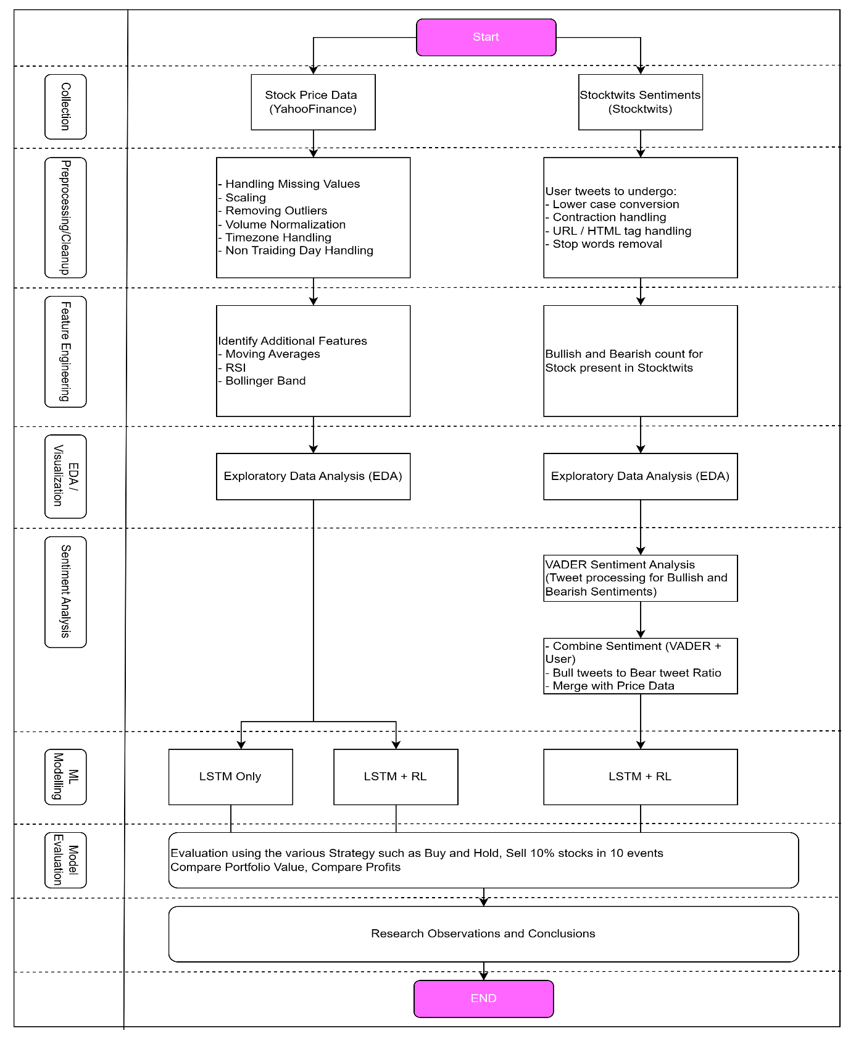Figure 3.1: High-level Flowchart for Research Approach

## Algorithm Selection Rational

In this phase, several machine learning algorithms were extensively studied, reviewed, as mentioned in CHAPTER 2 LITERATURE REVIEW , for both price predictions/trading signal and sentiment identification.



### Price/Trading signal related algorithms

#### LSTM – Long Short-Term Memory

**Architecture:**

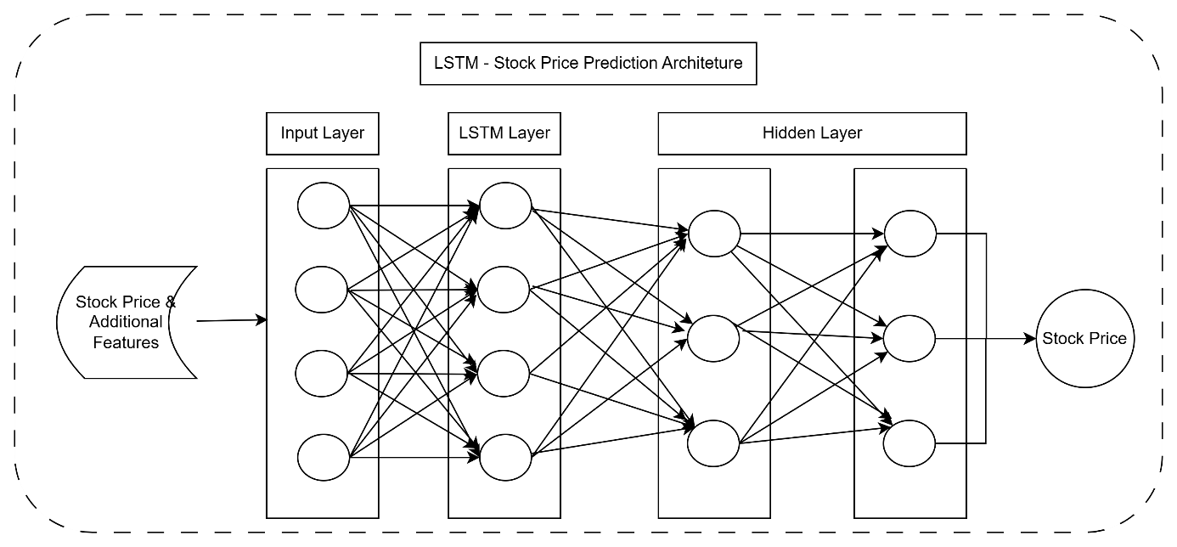

Figure 3.2: LSTM logical architecture

Table 3.1: Stock Price Prediction - LSTM Pros and Cons

|  |  |
| --- | --- |
| Pros | Cons |
| Sequential Modelling: LSTM is well-suited for sequential data like time series, making it effective for capturing temporal dependencies in stock price data. | Limited Context: LSTM models might struggle with capturing long-term dependencies in data, especially when the market dynamics change abruptly. |
| Non-linear Patterns: It can capture non-linear patterns in the data, which are common in financial time series. | Overfitting: There's a risk of overfitting, particularly when the dataset is small, which can lead to poor generalization on unseen data. |
| Feature Extraction: LSTM can automatically extract features from the raw data, reducing the need for manual feature engineering. | Lack of Adaptability: LSTM models might not adapt to changing market conditions or sudden events since they rely solely on historical data. |
| Interpretability: The model can be relatively interpretable, allowing analysts to understand how past information influences future predictions. |  |

#### Neural Network (LSTM) + Unsupervised Learning (RL)

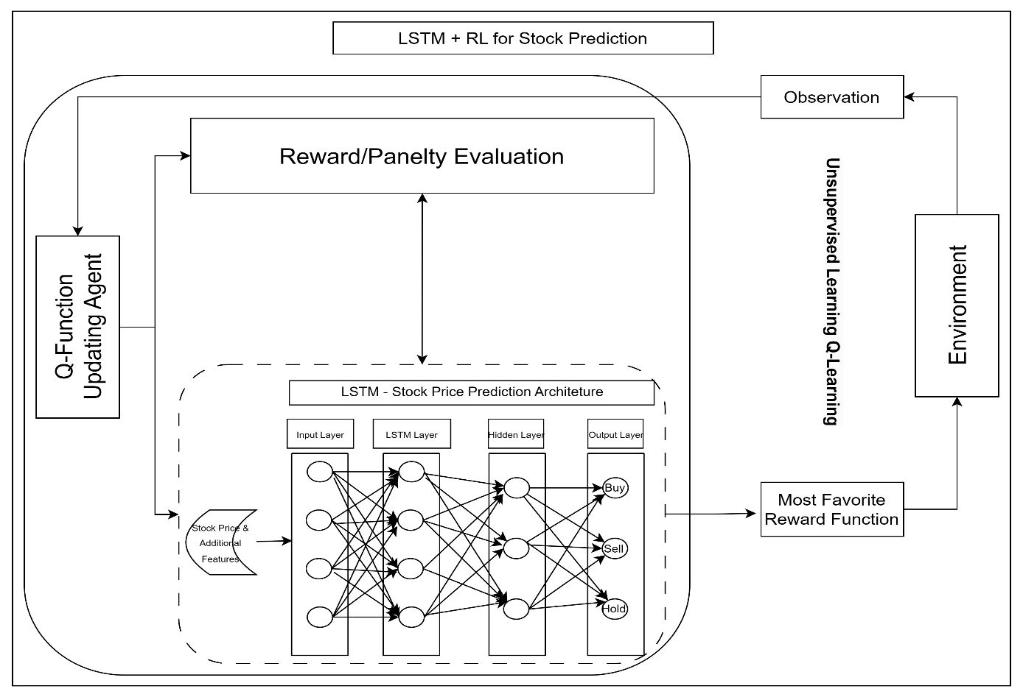

Figure 3.3: LSTM + RL architecture

ADD STEPS FOR DQN

Table 3.2: RL + LSTM Approach Pros and Cons

|  |  |
| --- | --- |
| Pros | Cons |
| Adaptability: RL algorithms can learn adaptive trading strategies by interacting with the environment, allowing the model to adjust to changing market conditions. | Complexity: Combining LSTM with RL increases the complexity of the model, requiring expertise in both deep learning and reinforcement learning techniques. |
| Dynamic Portfolio Management: RL can optimize portfolio allocation based on current market conditions, maximizing returns and minimizing risks. | Data Efficiency: RL algorithms typically require a large amount of data and extensive training, which might not be feasible in financial markets due to limited historical data and high volatility. |
| Exploration-Exploitation Balance: RL algorithms can strike a balance between exploration (trying out new strategies) and exploitation (leveraging known profitable strategies), which is crucial in dynamic markets. | Computational Resources: RL algorithms can be computationally intensive, requiring substantial computational resources for training and inference. |
| Risk Management: RL can incorporate risk management strategies into the decision-making process, helping to mitigate potential losses. | Black Box Nature: RL models can be less interpretable compared to traditional statistical models, making it challenging to understand the reasoning behind specific trading decisions. |

*This research will leverage LSTM individually and also in combination with Reinforcement Learning for analysis offering advantages in adaptability, dynamic portfolio management, exploration-exploitation balance, and risk management, which suits the research objectives.*

### Sentiment Prediction Algorithms

Considering the research objectives of establishing the relationship between the stock prices and market sentiment, various sentiment analysis algorithms were considered such as VADER, SentiWordNet, and Deep Neural Networks (DNNs) for social media sentiments.

#### VADER

Table 3.3: Sentiment Analysis - VADER Pros and Cons

|  |  |
| --- | --- |
| Pros | Cons |
| Pre-trained Lexicon: VADER utilizes a pre-trained lexicon specifically designed for sentiment analysis, which includes stock-related terms and their associated sentiment scores. | Limited Contextual Understanding: VADER's lexicon-based approach may not fully capture the context and subtleties of sentiment expressed in stock tweets, leading to potential misinterpretations. |
| Fast and Efficient: VADER is computationally efficient and can quickly analyse large volumes of text, making it suitable for real-time sentiment analysis of stock tweets. | Dependency on Lexicon Quality: The effectiveness of VADER heavily depends on the quality and coverage of its pre-trained lexicon, which may not encompass all stock-related terms and sentiments. |
| Rule-based Approach: VADER employs a rule-based approach that can capture sentiment nuances and context-specific sentiment expressions commonly found in stock-related tweets. |  |

#### SentiWordNet

Table 3.4: Sentiment Analysis - SentiWordNet Pros and Cons

|  |  |
| --- | --- |
| Pros | Cons |
| Word-Level Sentiment Scores: SentiWordNet provides sentiment scores at the word level, allowing for more granular sentiment analysis compared to VADER. | Sparse Sentiment Annotations: SentiWordNet may lack sufficient annotations for specific stock-related terms or industry-specific jargon, leading to less accurate sentiment analysis results. |
| Lexical Resource: SentiWordNet can be useful in cases where stock-related terms are not adequately covered by other sentiment analysis tools, as it offers a broader coverage of general vocabulary. | Complexity and Ambiguity: Assigning sentiment scores based on word senses in SentiWordNet can be complex and prone to ambiguity, especially in financial contexts where words may have multiple meanings. |
| Integration Flexibility: SentiWordNet scores can be integrated with other sentiment analysis techniques, potentially enhancing the accuracy of sentiment analysis for stock tweets. |  |

#### Deep Neural Network

Table 3.5: Sentiment Analysis - Deep Neural Network (DNNs) Pros and Cons

|  |  |
| --- | --- |
| Pros | Cons |
| Learn Complex Patterns: DNNs can learn intricate patterns and relationships in textual data, potentially capturing subtle sentiment nuances present in stock tweets. | Data Dependency: DNNs require large amounts of labelled training data, which may be scarce or costly to obtain for sentiment analysis of stock tweets, especially with domain-specific annotations. |
| End-to-End Training: DNNs can be trained end-to-end, allowing for the automatic extraction of features from raw text data without the need for manual feature engineering. | Computational Resources: Training and fine-tuning DNN models can be computationally intensive, requiring substantial resources in terms of processing power and time. |
| Flexibility: DNN architectures such as LSTM or Transformer can handle varying lengths of input text, accommodating the often variable-length nature of tweets. | Interpretability: DNNs are often considered black-box models, making it challenging to interpret how they arrive at sentiment predictions for individual stock tweets, which may be crucial for understanding market sentiment dynamics. |

The choice between VADER, SentiWordNet, and Deep Neural Networks for sentiment analysis of stock tweets depended on factors such as the availability of labelled data, computational resources, and the desired balance between accuracy and interpretability. VADER and SentiWordNet offered simplicity and efficiency but lack coverage or granularity in sentiment analysis, while DNNs provide flexibility and potential for capturing complex patterns but required extensive data and computational resources.

The study chose to focus on sentiment analysis using VADER as it offers following advantages straight out of the box:

* Tailor-made for social media: VADER is particularly well-suited for analysing sentiment in social media content due to its ability to handle informal language, slang, and emoticons commonly found in tweets.
* Lexicon-based Approach: VADER relies on a pre-built lexicon of words and phrases with assigned sentiment scores. This lexicon is continuously updated and refined, making it effective for capturing the nuances of sentiment expressed in online text data.
* Rule-based Analysis: In addition to its lexicon, VADER also employs a set of rules and heuristics to interpret the sentiment of text. These rules take into account factors such as punctuation, capitalization, and degree modifiers (intensifiers and negations), which can influence the sentiment conveyed by a sentence. This rule-based approach enhances VADER's ability to accurately identify sentiment in stock tweets, where sentiment can be influenced by the tone and structure of the text.
* Valence Aware: VADER is "valence aware," meaning it is sensitive to the intensity and polarity of sentiment expressed in text. It can differentiate between positive, negative, and neutral sentiment, as well as quantify the intensity of sentiment expressed. This granularity allows VADER to provide more nuanced sentiment analysis, which is particularly useful for distinguishing between Bullish (positive) and Bearish (negative) sentiment in stock tweets.

*After carefully reviewing the various aspects, VADER was chosen to untangle the sentiments hidden in the social media tweets for its aptness to handle them really well.*

## Data Collection

As depicted in Figure 3.1: High-level Flowchart for Research Approach, the collection of target data, the very first step, plays an important determinant in shaping the overall journey of the research. The process involves gathering stock price data and tweets, which are generated at an exponential rate and exist in diverse forms and formats.

The data collection process began with the identification of relevant datasets encompassing historical stock prices. These OHLV datasets is obtained from YahooFinance. The research will directly use the YahooFinance API Integration in python. In order to incorporate the sentiments, this study extracted the tweets from the Stocktwits website. This is achieved via a custom written powershell scripts.



### Stock ticker selection

It is important to select the right stocks for analysis while keeping in mind the # of tweets available on the StockTwits data. As a result, the study focusses on the technology stocks as its scope. Following technology related stocks were prime candidates for this study:

Table 3.6: Stock ticker selection

|  |  |
| --- | --- |
| Stock | Reason for selection |
| Microsoft Corp  MSFT | Microsoft Technologies (MSFT) has been specifically chosen due to its recent prominence, notably for its collaboration with OpenAI and integration of numerous AI-related functionalities into its product suite. This engagement has sparked extensive discussions and sentiments across various social media platforms concerning the company's trajectory and innovations. |
| NVIDIA Corp  NVDA | NVIDIA Corporation (NVDA) has been specifically chosen due to its recent prominence in the field of graphics processing units (GPUs) and artificial intelligence (AI) technologies. NVIDIA CORPORATION's innovations and partnerships in AI, gaming, and data centre solutions have generated significant discussions and sentiments across various social media platforms, reflecting the company's influence and market perception. |
| Apple Inc  AAPL | Apple Inc. (AAPL) is a prime candidate for analysis due to its unparalleled influence in the technology and consumer electronics sectors. Renowned for its innovative product releases like the iPhone, iPad, and Macintosh computers, Apple consistently dominates discussions across social media platforms. |
| Tesla Inc  TSLA | Tesla Inc. (TSLA) stands out as a notable contender for analysis, driven by its disruptive presence in the automotive and renewable energy sectors. Tesla Inc has redefined traditional notions of transportation and energy consumption through its electric vehicles (EVs), solar energy solutions, and energy storage products. The company's cult-like following, characterized by passionate supporters and sceptics alike. |

### Timeframe selection

Post selection of the stocks scope, a decision was made to focus on the recent time for the analysis which spanned from 01-Jan-2023 to 15-March-2024.

## Data Source Description

### Stock Price Features

A detail description of the OHLVC dataset from Yahoo Finance is available in table below.

Table 3.7: Stock Price Data

|  |  |  |
| --- | --- | --- |
| Column | Type | Description |
| Date | Date | The date of the trading day. |
| Open | Numeric | The opening price of the stock on that trading day. |
| High | Numeric | The highest price reached by the stock during the trading day. |
| Low | Numeric | The lowest price reached by the stock during the trading day. |
| Close | Numeric | The closing price of the stock on that trading day. |
| Adj-Close | Numeric | The adjusted closing price, which factors in any corporate actions, such as dividends or stock splits, that occurred before the next trading day. |
| Volume | Numeric | The total number of shares traded on that trading day. |

The above historical data will be stored in a SQLLITE database for quicker retrieval later on.

Adj Close price is chosen as an important feature due to the following reasoning:

* The Adjusted Close price represents the stock's closing price adjusted for any corporate actions, such as dividends, stock splits, or mergers. This adjustment accounts for changes in the stock's price due to these events, providing a more accurate reflection of the stock's true value.
* As the closing price of the trading day, the Adjusted Close price encapsulates the final sentiment and market dynamics of the day's trading activity. It reflects the collective actions and decisions of market participants throughout the trading session.
* The Adjusted Close price is widely used by investors and analysts for technical analysis, trend identification, and forecasting. It serves as a key indicator of the stock's performance over time and is often referenced in charting and modelling.
* In trading strategies, the Adjusted Close price is significant for assessing the effectiveness of buy or sell decisions. The selected strategy may involve buying or selling stocks based on the Adjusted Close price due to its reliability as a closing reference point. This approach allows stakeholders to assess the stock's performance over a specific period and make informed investment decisions.
* Stakeholders may prioritize the Adjusted Close price for trading activities due to its stability and consistency as a closing price reference. It provides a standardized benchmark for evaluating the stock's performance relative to other securities and market indices.

### Sentiment Analysis Features

Given that Stocktwits have stopped supporting a direct python API integration, The study aimed to download the stock tweets by a custom written powershell script which can web-scrape and download the tweets json. Out of all the fields available in json download of the tweets, following features will be considered for the study:

Table 3.8: StockTwits Tweets Data

|  |  |  |
| --- | --- | --- |
| Column | Type | Description |
| message_id | Bigint | Message number |
| symbol | String | Stock that message focuses |
| tweet | Text | The content of the tweet |
| created_at | Datetime | Date when the tweet was created |
| Sentiment | String | User tagged sentiment (Bullish / Bearish /None) |

The study aims to generate the Sentiment Score as additional feature post preprocessing of the tweet and VADER algorithms will be deployed to assign sentiment scores to each tweet, indicating the positivity, negativity, or neutrality of the text. The study will focus on analysing the number of Positive/Negative/Neutral tweets in overall analysis.

## Feature Engineering

### Feature for Technical Indicators

Technical indicators capture different aspects of market behaviour, including trend direction, momentum, volatility, and overbought/oversold conditions. Incorporating these indicators helps the model understand the current market context and make more informed decisions based on historical patterns and signals.

Features based on technical indicators include:

* Moving Averages: Calculated by averaging the closing prices over a specified time period (e.g., [5 | 10 | 20 | 50 | 200]-day moving average).
* Relative Strength Index (RSI): A momentum oscillator that measures the speed and change of price movements. It ranges from 0 to 100 and is typically used to identify overbought or oversold conditions. Anything above 70 is considered overbought and below 30 is considered oversold.
* Bollinger Bands: Volatility bands placed above and below a moving average, indicating potential overbought or oversold conditions.
* MACD (Moving Average Convergence Divergence): A trend-following momentum indicator that shows the relationship between two moving averages.

At minimum, the study aims to explore the combination of 5-day, 10-day and 14-day moving averages indicator alongside Adj-Close price to establish relationship of the recent social media trends on the price action due to recentness of the messages.

### Feature for Sentiments

Sentiment Score: The research will aim to derive Sentiment Score as primary feature on the tweet. This will than be used to derive a sentiment for the tweet (i.e. Bullish/Bearish/Neutral).

## Pre-processing

The previous section discussed the collection and enrichment of data, which encompassed multiple dimensions, including time series data for stock prices and unstructured text data for tweets. To ensure data quality and preserve important hidden patterns and trends, various preprocessing steps such as data cleaning, normalization, lowercasing and feature extraction are applied to both stock prices and tweets as applicable.



### For Stock Price Data (Enhanced with Technical Indicators):

The price data for stock market prediction undergoes preprocessing/feature engineering to ensure its suitability for analysis. The following steps are undertaken:

* Identification of relevant features: One of the fundamental steps in pre-processing involves removing irrelevant variables such as Open, High, Low, and Volume and focus on Adj-Close. Data Cleaning: The stock price data will undergo cleaning to address missing values and outliers. Outliers such as a sudden jump due to some corporate announcement (corporate actions) or market manipulation that may skew the analysis are identified and either corrected or excluded from the dataset. Additionally, missing values and anomalies often occur due to factors like regional holidays when exchanges are closed, as well as special trading hours such as Diwali muhurta trading in India or Election Day holiday in Mumbai.
* Feature Engineering: Additional features, known as technical indicators, were computed from the raw stock price data to provide deeper insights into market trends and volatility. The research is considering to utilising Moving Averages primarily to provide the trend tracking indicator. For instance, when computing moving averages for a 5-day period, the first 4 rows would lack values and thus need to be excluded and same goes if computing 10MA or 20MA.
* Normalization and Standardization: To ensure consistency and comparability across different variables, numerical data, including the newly created technical indicators, are normalized or standardized. Normalization scales the data to a common range (0 to 1), while standardization adjusts the data to have a mean of 0 and a standard deviation of 1, making it suitable for analysis.

#### For Tweets (Producing Sentiment Scores/Counts):

Stocktwits data functions as a signal indicator reflecting user sentiment, which is typically categorized as Bullish, Bearish, or Neutral. To address this, the following processes are undertaken:

* Text Cleaning: Tweets undergo cleaning to eliminate special characters, punctuation, URLs, and non-alphanumeric characters, ensuring that only relevant text remains for sentiment analysis.
* Text Preprocessing: Techniques like tokenization, stemming, or lemmatization, and removal of stop words are applied to standardize and prepare the tweet text for sentiment analysis.
* Text Normalization: Cleaned text is converted to lowercase to standardize the format, simplifying subsequent text processing tasks like tokenization.
* Keyword Analysis: Specific words or phrases linked with bullish or bearish trends are identified through keyword analysis. This involves extracting key linguistic markers associated with optimistic or pessimistic views on stock performance, enhancing understanding of sentiment trends within tweets.
* Contextual Analysis: The context surrounding tweets is thoroughly examined to discern the underlying causes of bullish or bearish sentiment. Factors such as company news, financial reports, market trends, and analyst opinions are investigated to provide additional context to sentiment analysis.
* Aggregate Analysis: Sentiment scores or occurrences of key keywords across multiple tweets referencing the same entity are aggregated to identify overarching bullish or bearish trends. Statistical analysis techniques quantify the strength and significance of these trends, providing a robust understanding of sentiment dynamics.

However, there are certain caveats while developing the sentiments from the tweets as its reliability may be questioned due to the ambiguity surrounding users' underlying motivations. Another factor to consider is the timing of the tweet in relation to the price action—whether it occurred before (pretty useful for the analysis) or after the price action (than it is just a noise). It is quite possible that more and more users started tweeting as the stock is on uptrend or downtrend and hence sudden jump in the tweet volume could be seen on the charts. So, it's important to understand that an increase in the volume of tweets can sometimes be a common occurrence due to herd mentality.

In summary, during the preprocessing stage, it is imperative to eliminate any missing values, noise, or anomalies in the selected data. Inconsistencies in the chosen data, particularly in stock market tweets, can lead to unreliable results or mispredictions of the test data. Such inaccuracies could have severe consequences if the model were implemented in a real-market scenario, potentially resulting in significant financial losses. Therefore, meticulous attention to steps mentioned above is essential to mitigate risks and ensure the reliability of subsequent analyses and predictions.

## Visual Analytics

In recent years, the field of data visualization has seen significant advancements, exponentially enhancing our understanding of complex datasets. The concept of information visualization involves the use of computer-supported interactive visual representations of abstract data to augment cognitive capabilities. This approach aims to provide a firsthand overview of complex data patterns, leveraging graphical formats such as charts, graphs, and maps, which are more conducive to the human brain's image-processing abilities compared to traditional tabular formats.

A key principle in visual analytics is to analyse first, highlighting the important aspects, followed by zooming, filtering, and further analysis, providing details on demand. Employing interactive techniques like focus and context optimization, visual analytics aims to build effective interfaces tailored to the human visual system.

Through visual analytics, data can be presented in a condensed form on interactive dashboards, facilitating easy comprehension of current status and future trends. Each visualization can interact with others, highlighting impactful changes between different data variables. This methodology proves particularly effective when dealing with large and complex datasets, such as stock data, which may be challenging to grasp without domain expertise.

One of the primary challenges in analysing stock-related data is information overload, where the abundance of variables can lead to overlooking or misinterpreting pivotal information, resulting in false predictions and missed opportunities. Visual analytics addresses this issue by facilitating intuitive analysis of stock data while concealing its inherent complexity. By enabling more accurate and rapid prediction, visual analytics serves as a valuable solution to enhance decision-making in stock price analysis.

## Model Evaluation

In this stage, when one or more classification models have been generated the models needs to be interpreted and evaluated to assess their performances. As such, the modes built for stock prediction is evaluated by deriving the parameters from the Accumulated Return, Cumulative Return, Sharpe Ratio or Returns with respect to a Benchmark. A brief definition of the term is as follows:

* Cumulative Returns: Cumulative returns measure the total returns generated by the investment strategy over a specified period.
* Accumulated Return: Accumulated return represents the total return accumulated by an investment strategy over a specific duration.
* Returns against a Benchmark Index: Returns against a benchmark index compare the performance of an investment strategy or portfolio to that of a selected benchmark index. This comparison allows investors to assess how well their investment strategy has performed relative to a standard reference point.
* Returns against Systemic Liquidation Strategy: One amongst various strategy applied is delve into the efficacy of a deliberate approach, involving the systematic liquidation of stock holdings across a sequence of 10 transactions, each strategically timed at 10 discrete intervals within a predetermined timeframe.

These metrics shall provide a comprehensive evaluation of the model's predictive power, profitability, and risk-adjusted performance.

## Summary

CHAPTER 3: RESEARCH METHODOLOGY delved into foundational work of modelling for both stock price dynamics and social media sentiment, providing a rationale for the selection of machine learning methods pertinent to the research objectives. It initiated with a comprehensive discourse on Algorithm Selection, elucidating the criteria governing model choice within specific contexts. This chapter laid the groundwork for subsequent section detailed in CHAPTER 4: RESULTS AND DISCUSSION spanning data selection, preprocessing, and model evaluation, with a view on leveraging visual analytics to extract actionable insights. Notably, it explored the adoption of unsupervised learning methods, particularly DQN-based Reinforcement Learning, focusing on the autonomous learning potential of its reward function in discerning successful strategies. Algorithmic considerations evaluated the efficacy of LSTM and RL+LSTM approaches for price prediction, while sentiment analysis assesses VADER among other available methods. Detailed elucidation on data collection and preprocessing techniques for both stock prices and tweets is provided, encompassing technical indicators, sentiment analysis features, and attention to data normalization, text cleansing, and sentiment scoring. The chapter culminated in a discussion on model evaluation metrics, spanning metric-based and strategy-based assessments, to gauge predictive power and risk-adjusted performance.

# ANALYSIS

## Introduction

This chapter delves into the practical aspect of analysis, model building, tuning and evaluation of price and tweets. This will focus on discerning any co-relationship between the price action and social media tweets. As described in previous chapter, the initial step involves meticulous data preprocessing to ensure data availability for exploratory data analysis (EDA) and application of machine learning models. Following data preprocessing, EDA analysis is conducted, encompassing univariate and bivariate analysis to discern correlations, eliminate extraneous data, and identify outliers, which are then appropriately treated as outlined in Research Methodology. Subsequently, the chapter addresses feature selection to identify the most pertinent features for price action and sentiment analysis. A combination of machine learning models is then constructed, and the optimal model is determined based on the detailed discussion on model hyper tuning. Subsequently, CHAPTER 5: RESULTS AND DISCUSSION will focus on the outcome of this Analysis phase, examining the effectiveness of approach with respect to the set objectives.

## Data Selection

Price history dataset comprises historical stock price data for the in-scope stocks. It sets the foundation for analysing past trends and patterns. StockTwits history dataset includes a collection of historical tweets for in-scope stocks, sourced from social media platforms such as StockTwits. These offers valuable insights into public sentiment and market perceptions surrounding the target stocks.

Table 4.1: Data Selection Criteria

|  |  |  |  |
| --- | --- | --- | --- |
|  | Twitter Data (Stocktwits) | Price History | |
| Period | 1-Jan-23 to 15-Mar-24 | | |
| Stocks | AAPL, MSFT, NVDA, TSLA | | |
| Source | Stocktwits API | Yahoo Finance | |
| Features | * Tweet_created_at * Tweet * User_sentiment | * Date * Open * High | * Low * Close * Volume |

The entirety of this data, including any enhancements conducted through preprocessing, will be stored within the SQLite database, facilitating seamless retrieval for subsequent phases of analysis.

Please note (unless specified), The EDA will apply following colour schema:

|  |  |
| --- | --- |
| AAPL – Apple | MSFT – Microsoft |
| NVDA – NVIDEA | TSLA - Tesla Inc |

### Price history at a glance

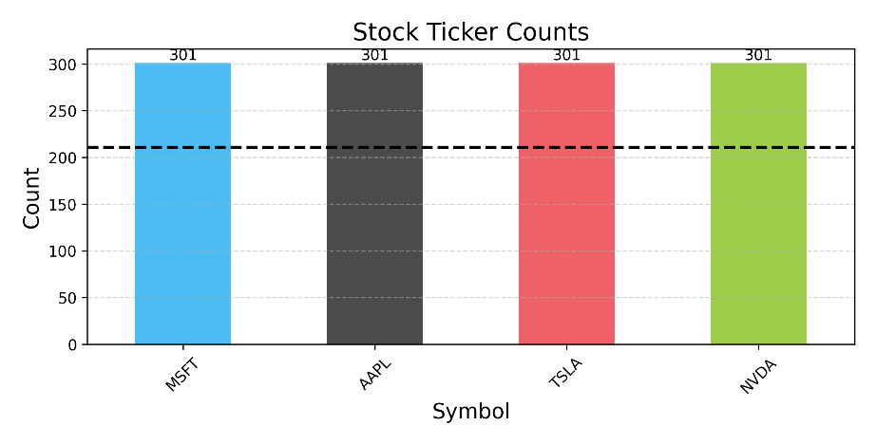Figure 4.1: Stocks Statistics

Table 4.2: Price statistics at a glance (NEEDS WORK Stock wise count..)

|  |  |  |  |  |  |  |
| --- | --- | --- | --- | --- | --- | --- |
|  | Date | Close | Open | Volume | High | Low |
| count | 1204 | 1204 | 1204 | 1204 | 1204 | 1204 |
| mean | 08-08-2023 | 284.51 | 284.11 | 66666277.41 | 288.17 | 280.20 |
| min | 03-01-2023 | 108.10 | 103 | 10176600 | 111.75 | 101.81 |
| 25% | 21-04-2023 | 185.63 | 185.46 | 35229700 | 187.31 | 183.49 |
| 50% | 09-08-2023 | 249.76 | 249.14 | 50882050 | 254.01 | 244.93 |
| 75% | 24-11-2023 | 345.14 | 345.72 | 92418075 | 347.77 | 340.36 |
| max | 14-03-2024 | 926.69 | 951.38 | 306590600 | 974 | 896.02 |
| std |  | 131.18 | 131.16 | 45227548.88 | 133.25 | 128.71 |

* Total of 1204 rows with each stock having 301 OHLV records and 70% of it (211 records, represented by black dotted line) is used for training.
* The study will focus on Close primarily and technical features derived of it.

### Sentiment history at a glance (NEEDS WORK Stock wise count..)

Table 4.3: Sentiment Statistics

|  |  |  |  |  |  |
| --- | --- | --- | --- | --- | --- |
|  | Date | Bearish | Bullish | Neutral | Bull/Bear Ratio |
| count | 1422 | 1422 | 1422 | 1422 | 1422 |
| mean | 30-07-2023 | 204.77 | 285.46 | 140.2 | 1.89 |
| min | 06-12-2022 | 1 | 3 | 2 | 0.48 |
| 25% | 03-04-2023 | 36 | 66 | 34 | 1.16 |
| 50% | 30-07-2023 | 83.5 | 148 | 72 | 1.6 |
| 75% | 26-11-2023 | 249.75 | 317 | 159 | 2.26 |
| max | 23-03-2024 | 3230 | 6557 | 3518 | 23 |
| std |  | 314.61 | 464.83 | 225.24 | 1.4 |

## Data Preprocessing

This sub-section involves explaining the preprocessing steps applied on Price and StockTwits data. This will help to ensure that dataset is clean and ready for EDA and application of machine learning models.



### Price – Preprocessing & Trends

This preprocessing stage involves following observations:

* No NaN or NULL records present and hence no additional imputation is required
* No duplication and hence no deletion is required

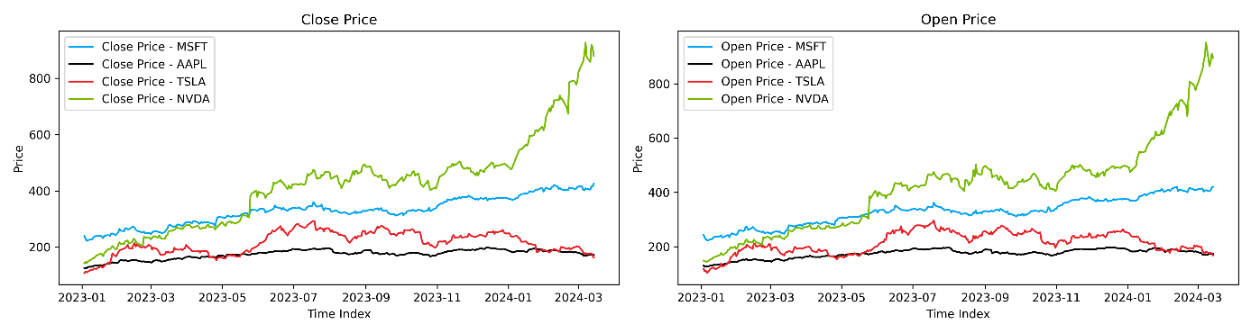

Figure 4.2: Price Trend – Close and Open

* Figure 4.2: Price Trend – Close and Open below shows the trend for the 4 stocks for selected duration; MSFT and NVDA (in particular) have shown a significant uptrend on the back of Open AI integration and increased influence of GPU adoption in AI (AI being top focus area recently).

### Outlier detection

Figure 4.3: Close price outlier detection , below, box plot shows that there are some outliers on NVDA ticker explained by the prevailing bullish a bullish sentiment trend on the back of all the innovation happening in the AI space.

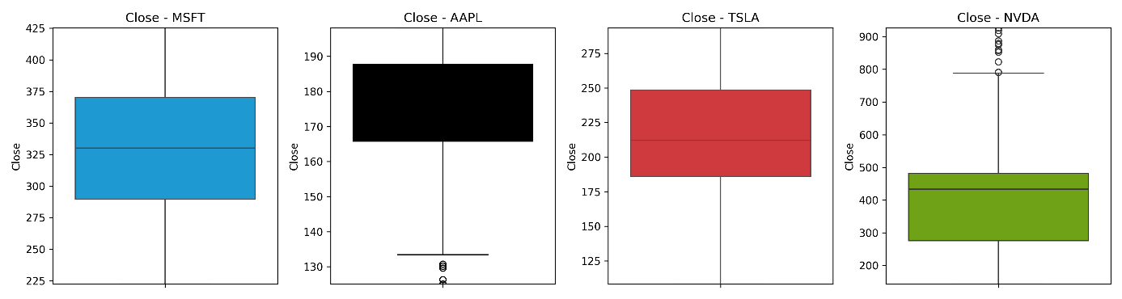

Figure 4.3: Close price outlier detection

### StockTwits

Following operations are performed on tweet and stored in a new column clean_tweet:

* Convert the tweet to lower case
* Apply contraction
* Stop word removal
* Removal of HTML tags/links/punctuation etc

## Feature Engineering

### Price – Technical indicator

Stock price history table feature engineered for:

* MA5
* MA10
* MA20

Can be a graph here to explain the movement of close price with the MAs and say that a dip or increase on these explains the trend

We see in the graph that the best values to measure the moving average are 10 and 20 days because we still capture trends in the data without noise.

### StockTwits – sentiment score

VADER sentiment analyser is applied to the cleaned tweets, resulting in the generation of a compound score. Following thorough scrutiny, a new feature, referred to as Vader Sentiment, is engineered from these scores to give a tweet Positive / Negative and Neutral trend.

## Exploratory Data Analysis (EDA)

Exploratory data analysis (EDA) involves an in-depth examination of the dataset used in for study to dissect it in multiple dimensions so that a thorough understanding of the data is achieved. This section explores various aspects of the data, including the distribution of stock prices, sentiment scores derived from VADER analysis, and any potential correlations between sentiment and stock price movements.

EDA will be completed keeping following points:

* Explore the data and identify the story of stocks
* Validate each and every feature and identify its relevance
* Draw plot to understand the relationship between different features
* Perform univariate and bivariate analysis.
* Identify any corelation that exists



### EDA for Price History

This section explores the distribution of stock prices, statistical measures such as mean, median, standard deviation, and quartiles to summarize the central tendency and variability of stock prices. Plots are used to visualize the distribution of stock prices over time, providing insights into trends, seasonality, and volatility.

#### Price Distribution

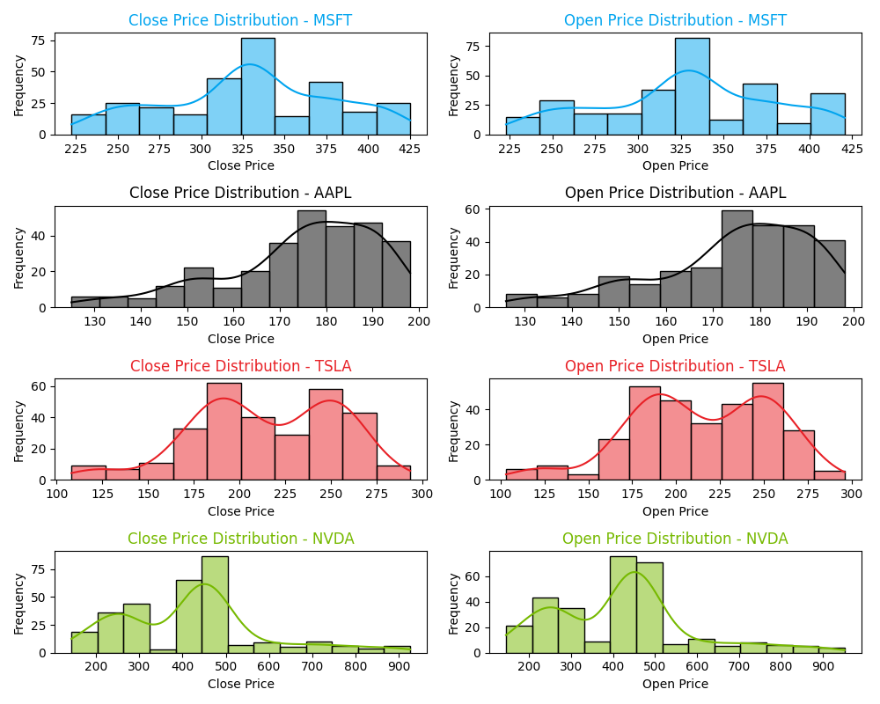

Figure 4.4: Price Distribution

#### Daily Price Movement:

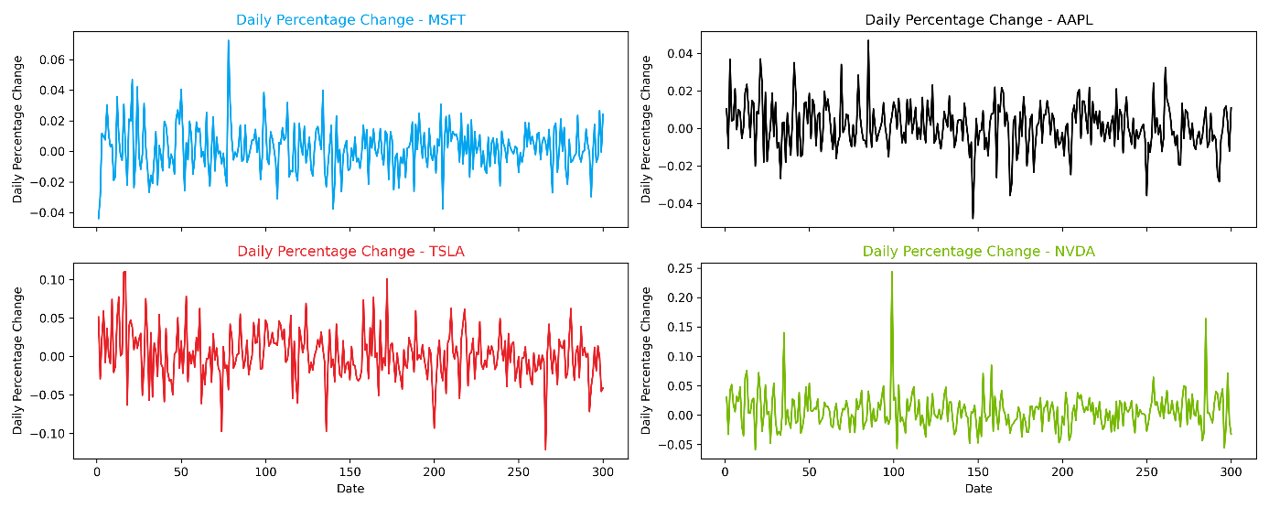

Figure 4.5: Daily price movement

#### Expected Returns

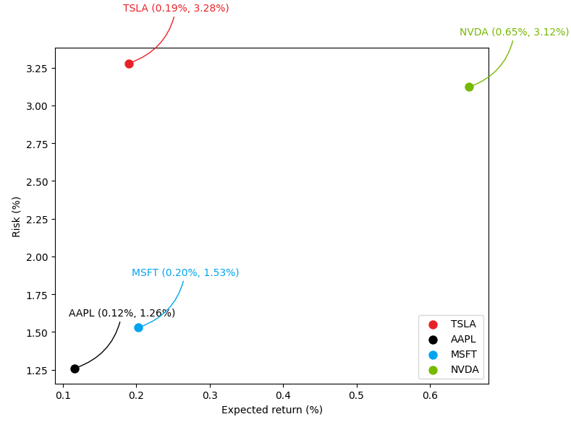

Figure 4.6: Stock wise Expected Returns

* NVDA exhibits the highest mean return and standard deviation of returns, indicating potentially higher returns but also higher risk.
* AAPL and MSFT have relatively lower mean returns and lower standard deviations of returns, suggesting lower risk but also potentially lower returns.
* TSLA falls between NVDA and AAPL/MSFT in terms of mean return and standard deviation of returns, indicating moderate risk and potential returns.

#### Heatmap of Price Correlation

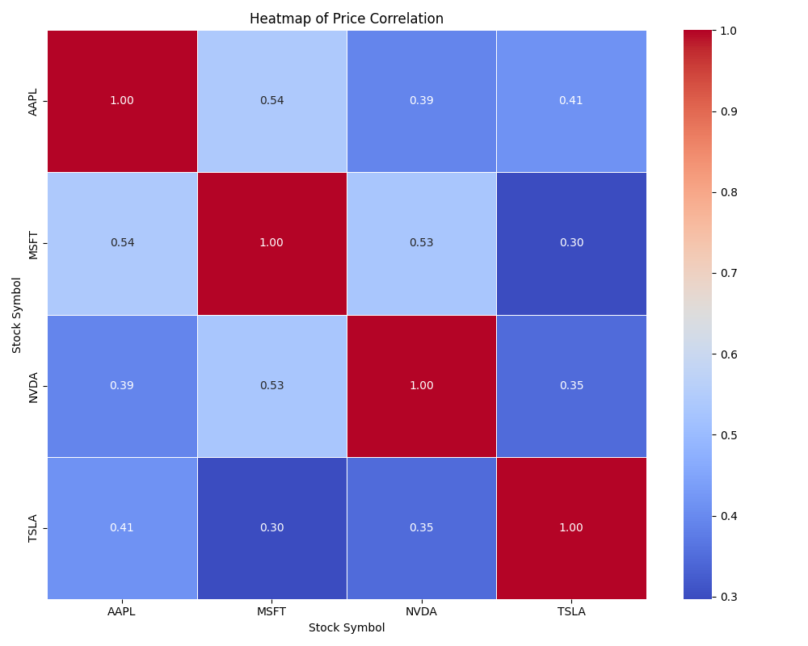

Figure 4.7: Heatmap for price correlation

* MSFT and NVDA: A moderately positive relationship, with a coefficient of approximately 0.53. This correlation may be attributed to their involvement in the realm of artificial intelligence (AI) development, with both companies leveraging each other's expertise and technologies to advance their respective AI-driven initiatives and product offerings.
* AAPL and MSFT: The correlation analysis reveals a notably positive relationship between the performance of the stocks, evidenced by a correlation coefficient of approximately 0.54. This correlation may reflect the interdependence stemming from their collaborative efforts in technological advancements, such as cross-platform integrations and joint ventures in cloud computing services.
* AAPL and NVDA: While a positive correlation exists, it appears comparatively weaker, standing at around 0.39. This correlation, though not as robust, could still be influenced by indirect associations, such as shared market segments.

### EDA for Sentiments

The study focusses on the impact of sentiment factors, such as sentiment intensity, sentiment polarity, and temporal trends, on stock price predictions. This analysis involves:

#### Sentiment Count Analysis – aggregate

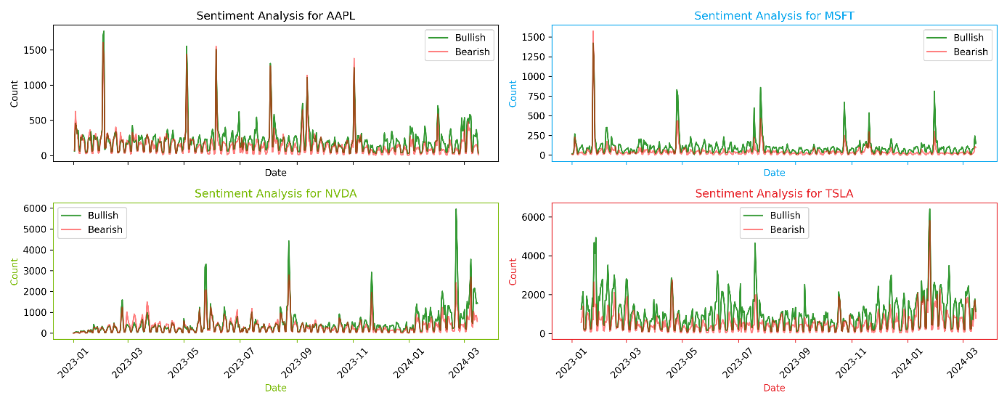

Figure 4.8: Sentiment count aggregate

#### Sentiment Count Analysis - Detailed

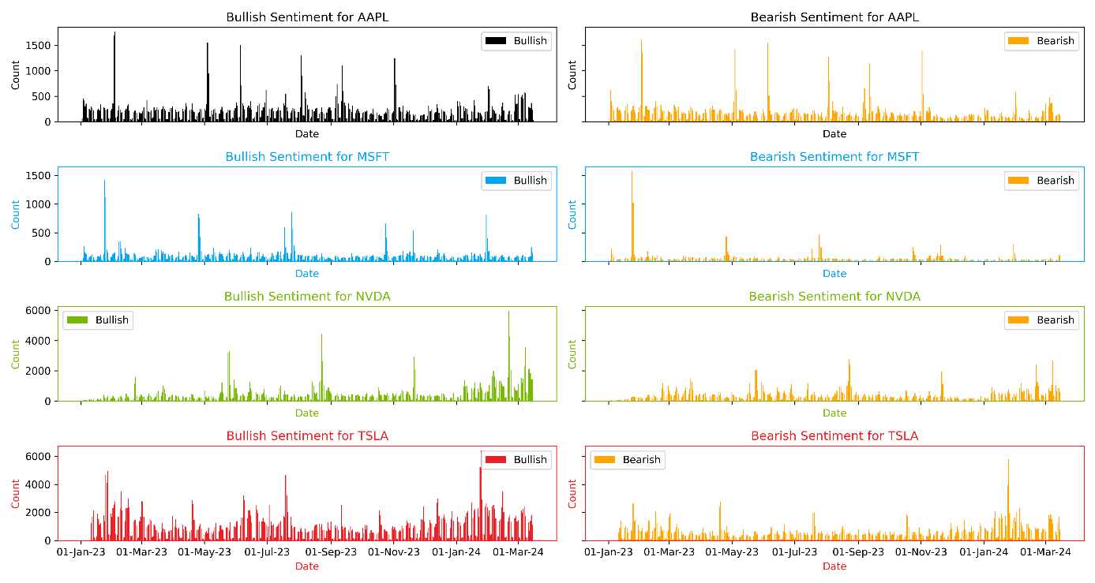

Figure 4.9: Bullish and Bearish count detailed (0.5 threshold)

#### Bearish and Bullish comparison based on the threshold tuning

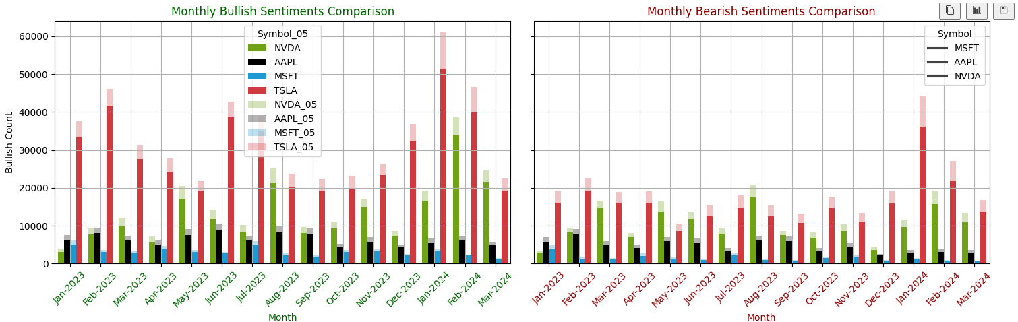

#### Word Cloud – Aggregate

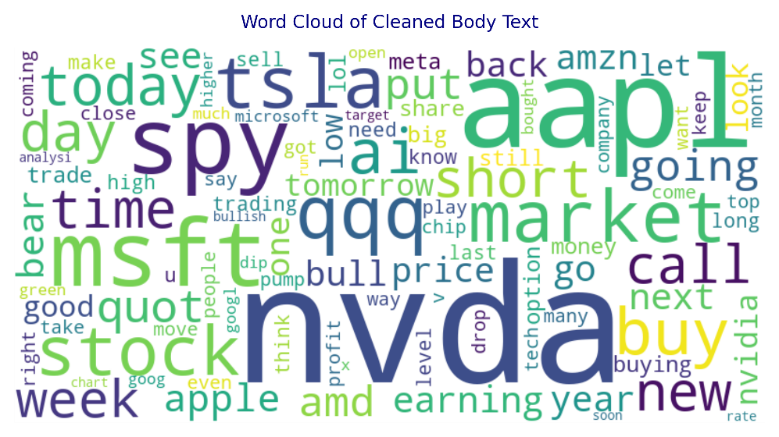

Figure 4.10: Word count aggregate

#### Word Cloud – Stock Level

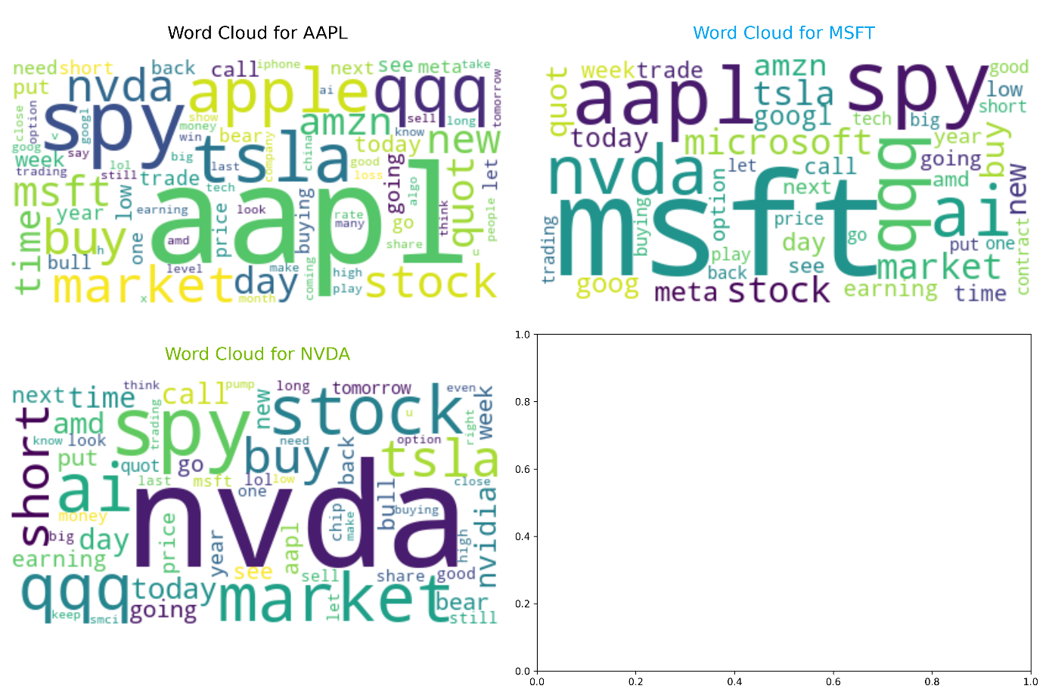

Figure 4.11: Word count detailed

#### Tweet Volume Over Time

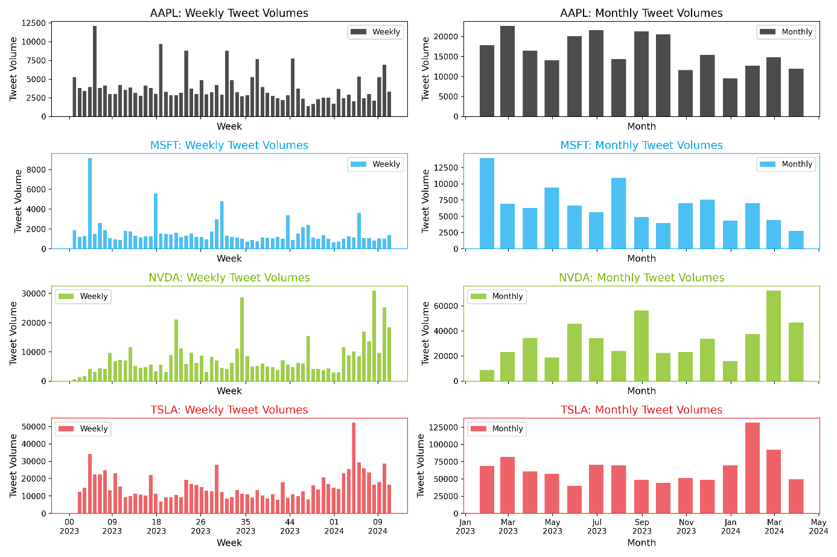

Figure 4.12: Tweet volume over time

### EDA on Combined Analysis

#### # Of tweets & Stock Price activity

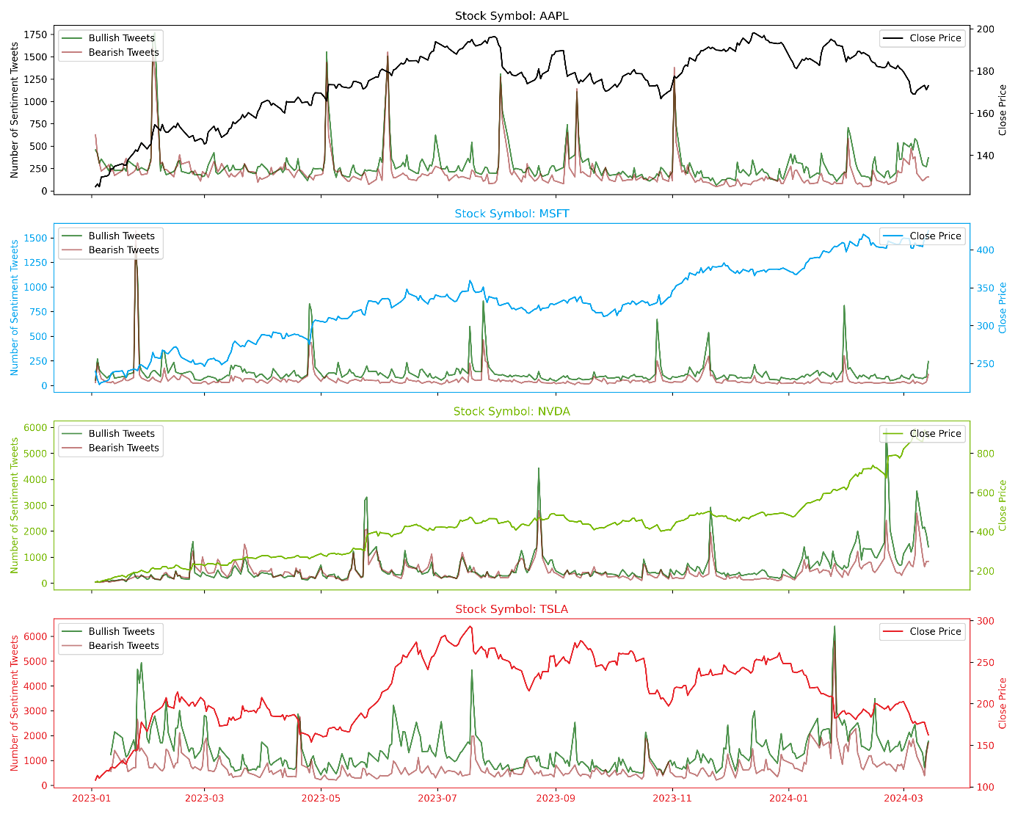

Figure 4.13: # of tweets & stock price activity

#### Bull to Bear Ratio & Stock Price activity

#### 

#### Corelation Analysis

Correlation analysis is conducted to examine the relationship between sentiment scores derived from stock tweets and stock price movements. Pearson correlation coefficient or Spearman rank correlation coefficient is computed to quantify the strength and direction of the relationship between sentiment and stock prices. Additionally, visualizations such as scatter plots and correlation matrices are used to visualize the relationship between sentiment and stock prices, aiding in the interpretation of correlation results and identification of potential patterns or trends.

#### Scatter Plot of Sentiment Score vs. Price Change

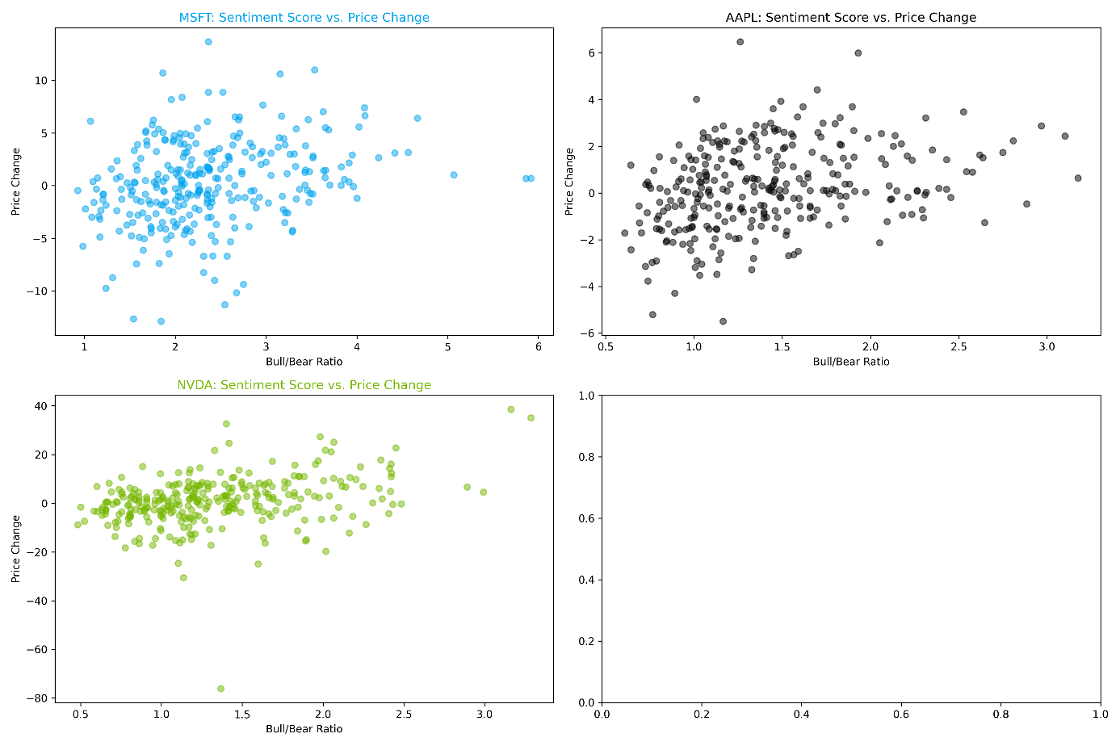

Figure 4.14: Sentiment score vs Price change

## Model Building and Tuning

This section implements proposed ML models described in Section 3.3 Algorithm Selection Rational. The research will engage in following distinct methodologies:

* VADER for sentiment analysis
* LSTM (Long Short-Term Memory) as a standalone predictor
  + 1-year range and 5-year range
* Fusion of LSTM with Reinforcement Learning (RL)

This section will share a comprehensive insight into the strengths, weaknesses, and implications of each model, thus illuminating the path towards frameworks for financial analysis.

### VADER

#### Tweet preprocessing

VADER is adept at processing raw social media tweets, effectively considering elements like punctuation, capitalization and emoticons. It employs a lexicon-based approach to analyse sentiment, thereby accommodating the nuances in text formatting and style. Consequently, to maintain the integrity and context of the received tweets, this research deliberately refrained from applying any preprocessing techniques to the raw tweet data. However, as part of experimentation, it explored the effectiveness of stopword removal for noise reduction purposes. The primary objective was to retain the original context and domain-specific language inherent in the tweet text, serving as a crucial measure to avoid excessive manipulation of the original content.

#### Model build/Tuning

Table 4.6: VADER Model parameters description

|  |  |  |
| --- | --- | --- |
| Parameter | Description | Reasoning |
| Lexicon Size | Number of words and phrases in the VADER lexicon. | A larger lexicon can capture a wider range of sentiment expressions, potentially improving sentiment analysis coverage. |
|  |  |  |
| Scoring Thresholds | Predefined thresholds for sentiment classification (positive, negative, neutral). | Adjusting thresholds can fine-tune the sensitivity and specificity of sentiment classification, optimizing sentiment analysis performance. |
|  |  |  |
| Sentiment Intensity Thresholds | Thresholds for distinguishing between mild, moderate, and strong sentiment expressions. | Intensity thresholds provide granularity in sentiment analysis, enabling differentiation between subtle and strong expressions of sentiment. |

##### Tuning scoring thresholds

Once VADER is applied to a given text, VADER assigns sentiment scores (positive, negative, neutral, and compound) to each text or sentence based on the presence of words with known sentiment polarity in its lexicon. By carefully selecting and fine-tuning these model parameters, we aim to optimize the performance of our predictive models and enhance the accuracy of stock price predictions based on sentiment analysis.

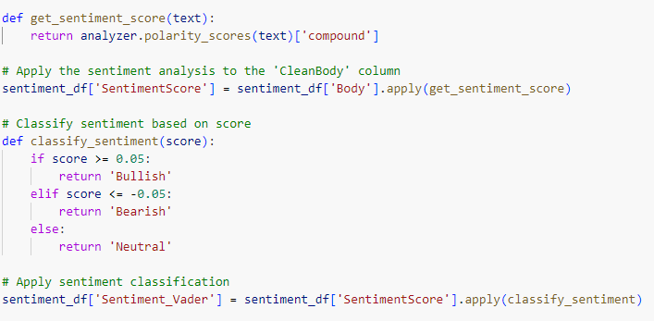

Figure 4.15: Tuning scoring thresholds

After analysing the various sentiments, a score of more than 0.05 is considered as Bullish and less than equal to -0.05 was considered as negative.

By looking at the VADER output as listed in the table above ; suggest that in order to use the VADER for sentiment analysis in the Socks may not work and a custom sentiment analyser needs to be invested into.

##### Lexicon updates

VADER is not a trainable model (i.e. Transfer learning), there are no traditional model parameters to tune which can be applied to the social media tweets however it may not be directly adaptable to the stock tweets which are domain specific. The study identified the domain specific words and enriched the VADER lexicon for the same.

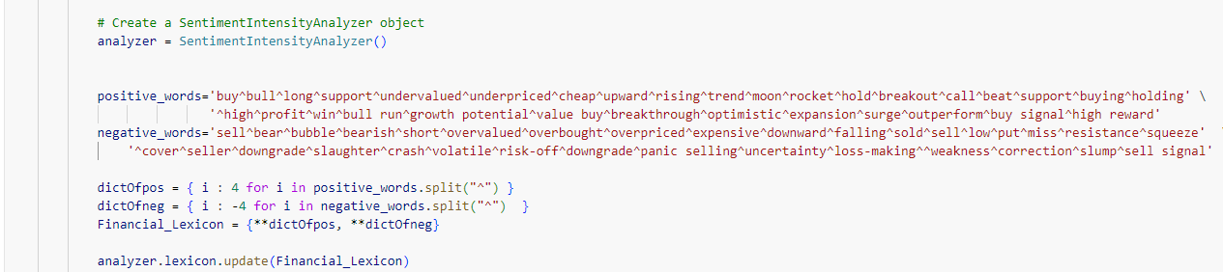

Figure 4.16: VADER lexicon updates

### LSTM Only

In this subsection, we delve into the intricacies of the training algorithm employed for LSTM (Long Short-Term Memory) models. LSTM is a type of recurrent neural network (RNN) architecture that is particularly well-suited for sequential data processing tasks, such as time series forecasting, natural language processing, and speech recognition. The training algorithm plays a pivotal role in optimizing the parameters of the LSTM network to effectively capture temporal dependencies and patterns within the input sequences.

#### Model Architecture

Unlike traditional RNNs, which suffer from the vanishing gradient problem and struggle to capture long-range dependencies in sequential data, LSTM networks incorporate specialized memory cells and gating mechanisms to address these challenges. The core components of an LSTM unit include the input gate, forget gate, cell state, and output gate, each of which regulates the flow of information through the network and facilitates the retention or discard of relevant temporal information.

The training of LSTM models typically involves the application of the Backpropagation Through Time (BPTT) algorithm. BPTT extends the backpropagation algorithm to recurrent neural networks, allowing gradients to be propagated through time across multiple time steps. During training, the input sequences are fed into the LSTM network, and the model's predictions are compared against the ground truth labels using a suitable loss function, such as categorical cross-entropy for classification tasks or mean squared error for regression tasks. The gradients of the loss function with respect to the model parameters are then computed using backpropagation, and the model weights are updated accordingly using an optimization algorithm, such as stochastic gradient descent (SGD) or its variants (e.g., Adam, RMSprop).

At a conceptual level, the architectural model employed in the model creation process was as follows. Subsequently, this model underwent hyperparameter tuning utilizing keras_tuner.

At a conceptual level (as illustrated in Figure 3.2: LSTM logical architecture), the physical model employed is as follows:

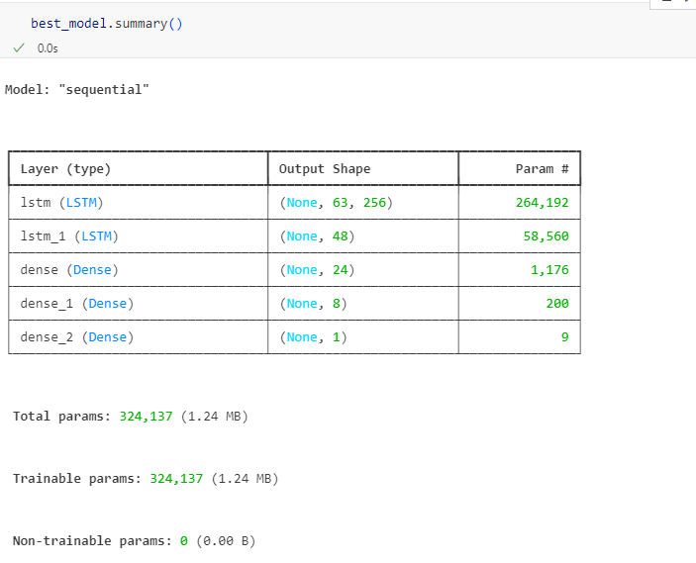

Figure 4.17: Physical model architecture

LSTM based Deep Neural Network (DNN) architecture is designed to capture complex patterns and relationships corresponding stock price movements. The architecture consists of multiple layers, each serving a specific purpose in the feature extraction and prediction process. Table below describes the important model parameter to consider for optimizations:

Table 4.4:LSTM Model parameters description

|  |  |  |
| --- | --- | --- |
| Component | Description | Reasoning |
| Input Layer | Input shape: (number of time steps, 1)  Features: Adj Close, MA5, MA10, MA20 | Time steps: Determined by historical data sequence  Features: 1 (Close price) |
| LSTM Layers | # of LSTM layers:  Variable [1, 2, 3] | Allow flexibility |
|  | Hidden units per layer:  Variable [64, 128, 192, 256] | Tunable for balancing model complexity and performance |
|  | Activation function:  'tanh' | Commonly used activation function for LSTMs |
|  | Dropout rate:  Variable [0.1, 0.15, 0.2] | Regularization to prevent overfitting |
|  | Return sequences:  True (False for final layer) | Needed for stacking multiple LSTM layers |
| Output Layer | Number of units/neurons: 1 | Output is a single value for regression |
|  | Activation function: None | Linear activation function for regression |
| Compile Parameters | Loss function:  Variable ['mse', 'mae’] | Tunable loss function for model optimization |
|  | Optimizer: Adam | Adam optimizer commonly used for its efficiency |
|  | Learning rate: Variable  [0.001, 0.0001] | Adjustable learning rate for optimizer |
| Training Parameters | Batch size: [16, 64] | Tunable batch size for training data |
|  | Number of epochs: max 50 | Adjustable number of epochs for training |

The criteria for selecting optimal hyperparameters revolve around maximizing training performance metrics such as validation loss convergence. The ultimate goal is to identify hyperparameter configurations that facilitate robust model training, ensuring effective prediction capabilities on unseen data.

#### Model Parameters & Tuning

In this subsection, the focus lies on elucidating the pivotal hyperparameters pertinent to training the LSTM models, which are fundamental for achieving optimal performance and convergence. Key hyperparameters, such as learning rate, batch size, and number of units, are paramount in shaping the efficacy and stability of the training process.

The tuning strategy leveraged Keras Tuner, a powerful tool for hyperparameter optimization. Keras Tuner offers an efficient approach to exploring the hyperparameter space, automating the process of selecting the optimal configuration for the LSTM model. It provides 3 different ways to apply optimization on the given model; listed below

##### Random Search

Random Search is a widely-used hyperparameter optimization algorithm due to its simplicity and ease of implementation. It randomly samples hyperparameter combinations from a predefined search space and evaluates their performance. While Random Search can be computationally efficient, its random nature may lead to suboptimal solutions, particularly in high-dimensional search spaces. Moreover, it does not adapt its search strategy based on past evaluations, potentially leading to inefficient exploration of the hyperparameter space.

##### Bayesian Optimization

Bayesian Optimization is a probabilistic model-based optimization technique that leverages Bayesian inference to guide the search process. By constructing a probabilistic surrogate model of the objective function, Bayesian Optimization efficiently balances exploration and exploitation, converging to near-optimal solutions with fewer evaluations compared to Random Search. However, Bayesian Optimization's effectiveness depends heavily on the choice of the surrogate model and its associated hyperparameters, which can introduce additional complexity and computational overhead.

##### Hyperband

Hyperband combines the efficiency of random search with a principled early-stopping mechanism inspired by successive halving. It systematically allocates resources to different hyperparameter configurations, focusing computational effort on the most promising candidates. Hyperband's ability to identify and discard poor-performing configurations early in the search process makes it particularly well-suited for large-scale hyperparameter optimization tasks. Additionally, its adaptive resource allocation strategy allows for efficient exploration of the hyperparameter space without the need for manual tuning or domain knowledge.

After conducting a thorough examination of the three available methodologies for hyperparameter tuning, the selection process culminated in the adoption of Hyperband as the preferred approach for optimizing the model.

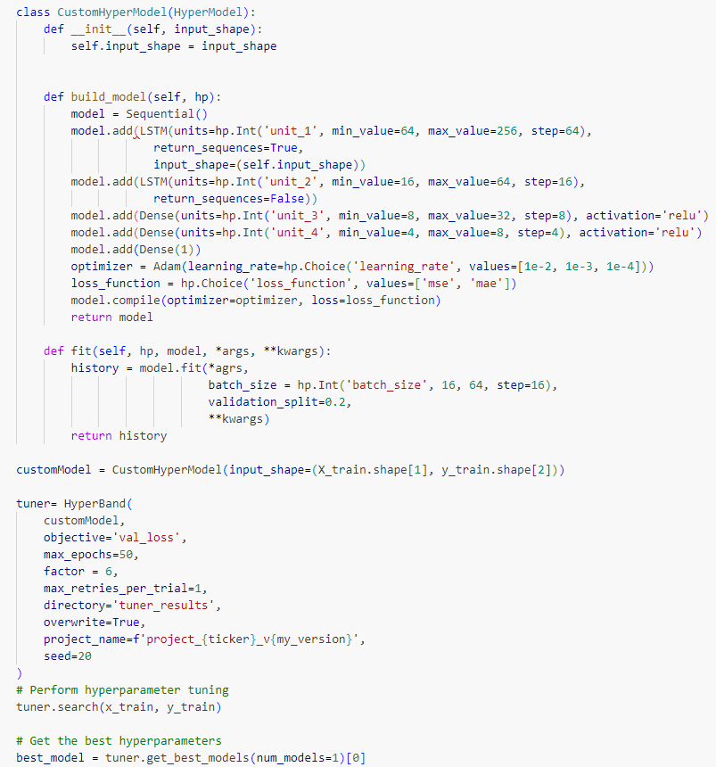

Figure 4.18: Hyperparameter Tuning for LSTM Model

#### Model Evaluation

Table 4.5: LSTM Predicted Close Prices

|  |  |
| --- | --- |
| **AAPL – Apple** | **MSFT – Microsoft** |
|  |  |
| **NVDA - NVIDEA** | **TSLA - Tesla Inc** |
|  |  |

### LSTM + RL

This section deals with the Deep Reinforcement Learning algorithms to come up with the portfolio value based on the initial portfolio cash and stocks. We conduct a comprehensive analysis of our predictive models and examine their performance in computing the trading model based portfolio value.

#### LSTM Model Architecture

We utilize various evaluation metrics to assess the effectiveness of our models, analyse their performance in detail, and investigate the impact of sentiment factors on stock price predictions.



Figure 4.19: Physical LSTM model architecture

#### RL Model Architecture



Figure 4.20: RL Model Architecture

#### Reward Function Design

One of the most important parameter tuning for the success of the LSTM + RL based algorithm is designing the reward function that will reward the right action (say a Buy or Sell or even hold) and help enrich the portfolio value. To explore the potential efficacy of combining Reinforcement Learning (RL) with Long Short-Term Memory (LSTM) networks, a rudimentary reward function was crafted.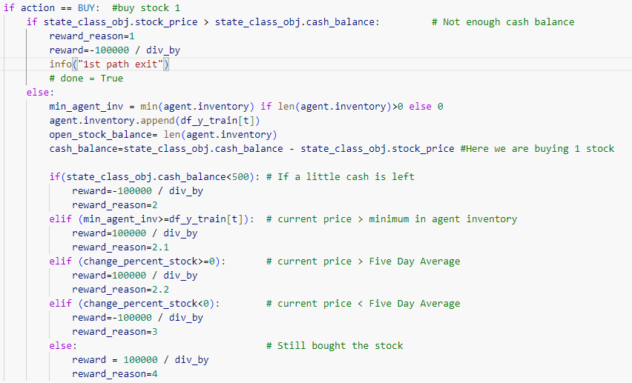

Figure 4.21: Buy signal reward function

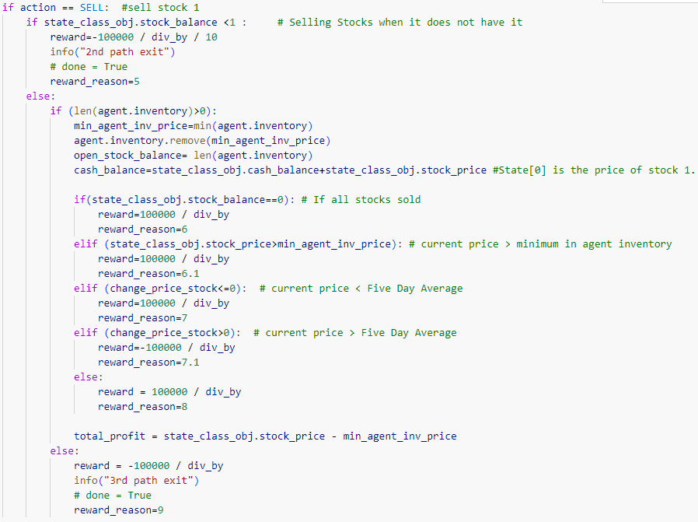

Figure 4.22: Sell signal reward function

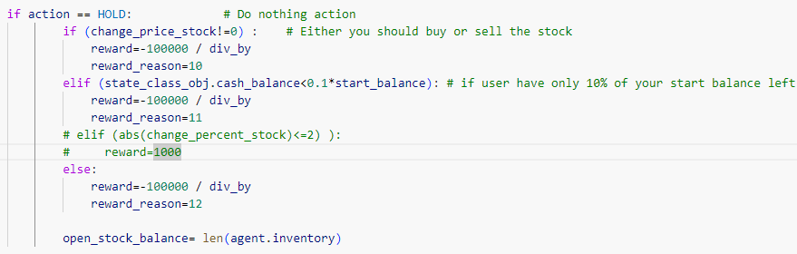

Figure 4.23: Hold signal reward function

#### Model Evaluation

|  |  |
| --- | --- |
| **AAPL – Apple Inc** | **MSFT – Microsoft Corp** |
|  |  |
| **NVDA - Nvidia Corp** | **TSLA - Tesla Inc** |
|  |  |

## Summary

# RESULTS AND DISCUSSION

Are the final results (table, figures,) findings, discussion, (10 pages mini)



## Introduction

This chapter discusses the results and conclusions derived from the analysis phase. It first explains the various metrics derived for 5 class imbalance techniques which were used and compares them to arrive at the best class imbalance technique having the highest accuracy and ROC curve. As a next step, metrics is created for the 9 models built with each of the 3 feature selection methods and comprehensive comparison metrics is created for the 1st Year. Also, the feature list is identified and its importance for the 1st year is explained. Post that the best identified model of 1st year is compared for feature selection, accuracy and ROC curve for models of 2nd, 3rd, 4th and 5th year which have been built using the features selected from the 1st year. At the end, the study answers the questions which were part of the research questions to find the optimum set of financial ratios which provides the best model, comparison of algorithms across multiple years using the optimal set of financial ratios and conclusions for Model drift analysis are derived using the above metrics for the individual year. 5.1 Model Results The comparison chart for the class imbalance models across the top 3 models from the 9 models is as follows.

The results of the top 3 models which built using the 5 Class Imbalance techniques on the 1st year dataset show the following observations.

• Among all the models Light GBM performed the best across individual Class Imbalance techniques and overall, also it performed the best.

• Oversampling and Under sampling techniques almost have the same accuracy across individual models.

• SMOTE+TOMEK which is the hybrid method performs the better than others and since it has a mix or both oversampling and under sampling, it can be treated as a balanced approach and considering it has the highest accuracy and AUC, for the Light GBM model, the study picks it to the best Class Imbalance technique.

The study used the feature selection methods namely Filter, Wrapper and Embedded methods to create a combination of 3 datasets. Each dataset has around 15 features which have been selected from the total 55 features post the EDA and data pre-processing. These 3 datasets are then used to create the 9 models as mentioned in this study and the top 3 model from these are identified. The following observations are made across these models.

• Light GBM performs the best across each of the 3 individual datasets and overall, also it performs the best.

• Dataset created using just the embedded feature selection technique provides the best metrics for the Light GBM model as compared to the dataset created using wrapper selection techniques and dataset created using common feature from both the techniques. 75 76 The comparison chart for the 3 feature selection datasets across the top 3 models from the 9 models is as follows Table 5.1.0-2 : Feature Selection - Comparison Method Model Accuracy AUC Recall Prec. F1 Wrapper Dataset (Step Forward / Step Backward) Extra Tree Classifier 0.8243 0.8982 0.9049 0.7796 0.8374 Random Forest Classifier 0.8642 0.9387 0.9076 0.8354 0.8699 Light Gradient Boosting Machine 0.9647 0.9936 0.9821 0.9493 0.9654 Embedded Dataset (RFE) Extra Tree Classifier 0.824 0.9045 0.8979 0.7827 0.8363 Random Forest Classifier 0.8619 0.9401 0.8851 0.8461 0.8651 Light Gradient Boosting Machine 0.9712 0.9959 0.9818 0.9557 0.9685 Common Dataset (Wrapper / Embedded) Extra Tree Classifier 0.8112 0.8847 0.8921 0.7681 0.8254 Random Forest Classifier 0.8581 0.9344 0.8942 0.8342 0.8631 Light Gradient Boosting Machine 0.9568 0.9899 0.9726 0.9429 0.9575

Finally, the study identifies that the best model after using class imbalance and feature selection is Light GBM. This model encompasses SMOTE+TOMEK as the best class imbalance technique and Embedded methods along with MinMax as the feature scaling technique.

## Model Drift Results

### VADER Misclassifications

|  |  |  |
| --- | --- | --- |
| tweet | **status** | **explanation** |
| $AAPL Break $140 please. I wanna see $120 by December 16th | VADER Misclassification | Despite VADER's classification as Bullish, the sentiment expressed is actually Bearish. User is expressing a desire for the price of AAPL stock to decrease ("Break $140") and reach $120 by a specified date ("December 16th"). This indicates a pessimistic outlook on the stock's performance, suggesting a belief that its value will decline. |
| Merry Christmas Bulls! $SPY $AMZN $GOOGL $AAPL $TSLA | User Misclassification (deliberate ? ) | User is wishing a "Merry Christmas" to "Bulls", which refers to investors who anticipate rising stock prices. Additionally, the inclusion of stock symbols like $AAPL and $TSLA suggests optimism or positivity towards the performance of these companies' stocks. Therefore, the overall sentiment conveyed in this statement is one of optimism or bullishness. |
| $AAPL  do you think Apple had a bad year? take a look at Tesla Inc. It?s down 50% from its yearly high. Who has shares of Tesla Inc? | VADER Misclassification | While the statement provides information about Tesla Inc. being down 50% from its yearly high, it does not express a clear opinion or sentiment about either Apple Inc. or Tesla Inc. It merely poses a question and provides factual information about the performance of Tesla Inc.'s stock. Therefore, the sentiment in this statement is neutral, as it does not convey positivity or negativity towards either company. |
| $AAPL Cook called off the car because the biggest exec they have plopped this down on Tim?s desk and said. ?Is this good enough?? ?? | VADER Misclassification | The use of phrases like "called off the car" and "Is this good enough?" suggests a decision or action taken by Apple Inc.'s CEO, Tim Cook, that may not meet expectations or may be perceived negatively. This could imply disappointment or concern regarding a project or decision made by the company's leadership, which aligns with a bearish sentiment. |

Comparison of DQN and DDQN

Finally, this subsection outlines the experimental setup for comparing DQN and DDQN algorithms, including variations in hyperparameters or training procedures. It specifies the performance metrics used for comparison and analyses the results of the comparative study. Insights into the relative strengths and weaknesses of DQN and DDQN are provided based on their convergence speed, stability, and final performance on validation data. The goal is to offer readers a comprehensive understanding of the differences between the two algorithms and their implications for stock market prediction tasks.

Evaluation Metrics:

Define the evaluation metrics used to assess the performance of the DRL model.

Discuss metrics such as average reward per episode, accuracy of sentiment predictions, or correlation between predicted and actual price movements.

In assessing the performance of our predictive models for stock and sentiment analysis, we employ evaluation metrics tailored to our specific use case, emphasizing benchmark return and buy vs. hold comparison. These metrics are crucial in quantifying the effectiveness of our models in generating returns compared to baseline strategies.

We employ a range of evaluation metrics to quantify the performance of our predictive models and gauge their accuracy in predicting stock prices. These evaluation metrics include:

Benchmark Return:

Benchmark return measures the performance of our predictive models relative to a predefined benchmark, such as a market index (e.g., S&P 500) or a buy-and-hold strategy.

It quantifies the percentage return achieved by our models over a specific period compared to the benchmark return over the same period.

A higher benchmark return indicates that our models outperform the benchmark, demonstrating their effectiveness in generating returns.

Buy vs. Hold Comparison:

Buy vs. hold comparison evaluates the performance of our predictive models against a simple buy-and-hold strategy, where an investor buys the asset and holds it for the entire period without any trading decisions.

It compares the cumulative return achieved by our models through trading decisions with the return generated by holding the asset without any trading activity.

A positive buy vs. hold comparison indicates that our models add value by making profitable trading decisions beyond what could be achieved through a passive buy-and-hold strategy.

By focusing on benchmark return and buy vs. hold comparison as our primary evaluation metrics, we aim to provide a practical assessment of the performance of our predictive models in real-world trading scenarios. These metrics offer valuable insights into the effectiveness of our models in generating returns compared to baseline strategies, helping investors make informed decisions and optimize their investment portfolios. Through rigorous evaluation and analysis of these metrics, we can gain a deeper understanding of the predictive power and value proposition of our models in the context of stock and sentiment analysis.

This section defines the evaluation metrics used to assess the performance of the trained DRL models and explains the evaluation procedure. Metrics such as cumulative reward and average return are discussed, along with their significance in measuring the effectiveness and generalization capability of the models. The process of evaluating the trained models on held-out validation data or through cross-validation techniques is detailed, emphasizing the importance of robust evaluation in reinforcement learning.

Comparison of DQN and DDQN

Finally, this subsection outlines the experimental setup for comparing DQN and DDQN algorithms, including variations in hyperparameters or training procedures. It specifies the performance metrics used for comparison and analyses the results of the comparative study. Insights into the relative strengths and weaknesses of DQN and DDQN are provided based on their convergence speed, stability, and final performance on validation data. The goal is to offer readers a comprehensive understanding of the differences between the two algorithms and their implications for stock market prediction tasks.

Evaluation Metrics:

Define the evaluation metrics used to assess the performance of the DRL model.

Discuss metrics such as average reward per episode, accuracy of sentiment predictions, or correlation between predicted and actual price movements.

In assessing the performance of our predictive models for stock and sentiment analysis, we employ evaluation metrics tailored to our specific use case, emphasizing benchmark return and buy vs. hold comparison. These metrics are crucial in quantifying the effectiveness of our models in generating returns compared to baseline strategies.

We employ a range of evaluation metrics to quantify the performance of our predictive models and gauge their accuracy in predicting stock prices. These evaluation metrics include:

Benchmark Return:

Benchmark return measures the performance of our predictive models relative to a predefined benchmark, such as a market index (e.g., S&P 500) or a buy-and-hold strategy.

It quantifies the percentage return achieved by our models over a specific period compared to the benchmark return over the same period.

A higher benchmark return indicates that our models outperform the benchmark, demonstrating their effectiveness in generating returns.

Buy vs. Hold Comparison:

Buy vs. hold comparison evaluates the performance of our predictive models against a simple buy-and-hold strategy, where an investor buys the asset and holds it for the entire period without any trading decisions.

It compares the cumulative return achieved by our models through trading decisions with the return generated by holding the asset without any trading activity.

A positive buy vs. hold comparison indicates that our models add value by making profitable trading decisions beyond what could be achieved through a passive buy-and-hold strategy.

By focusing on benchmark return and buy vs. hold comparison as our primary evaluation metrics, we aim to provide a practical assessment of the performance of our predictive models in real-world trading scenarios. These metrics offer valuable insights into the effectiveness of our models in generating returns compared to baseline strategies, helping investors make informed decisions and optimize their investment portfolios. Through rigorous evaluation and analysis of these metrics, we can gain a deeper understanding of the predictive power and value proposition of our models in the context of stock and sentiment analysis.

### Model Validation

Describe the process of validating the trained DRL model to ensure its effectiveness and generalization capability.

Explain how the model was tested on unseen data or through cross-validation to assess its performance on new market conditions.

In the model validation phase, our primary goal is to ascertain the effectiveness and generalization capability of the trained DRL model, specifically considering the DQN or DDQN algorithms employed. This involves rigorous testing on unseen data or through cross-validation techniques to evaluate the model's performance under varying market conditions.

Validation Dataset:

To validate the trained DRL model, we reserve a portion of the dataset that was not utilized during the training phase. This validation dataset comprises unseen stock price and sentiment data, ensuring that the model's performance is assessed on data it has not encountered before.

Cross-Validation:

Cross-validation serves as a robust technique to assess the generalization capability of the DRL model. We partition the dataset into multiple subsets (folds), iteratively training the model on one subset while validating on the remaining subsets. This process is repeated multiple times with different partitions, providing a more reliable estimate of the model's performance across various data samples.

Performance Evaluation:

We evaluate the performance of the DRL model using metrics tailored to our specific use case, such as benchmark return and buy vs. hold comparison. These metrics offer insights into the model's capacity to generate returns relative to baseline strategies and its performance under diverse market conditions. Additionally, traditional evaluation metrics like mean squared error (MSE), root mean squared error (RMSE), and mean absolute error (MAE) may also be utilized to quantify the accuracy of the model's predictions on the validation dataset.

Generalization Capability:

Through testing the model on unseen data and cross-validation, we assess its generalization capability – its ability to perform effectively on data it has not been trained on. A model with high generalization capability can adeptly capture underlying patterns and dynamics in the data, leading to reliable predictions in real-world scenarios. This attribute is critical for the model's practical utility in stock market prediction and sentiment analysis, ensuring that its predictions remain accurate and reliable when deployed in real trading environments.

For model drift analysis the study is using “Concept Drift” which is type of model drift wherein the statistical properties of the target variable which needs to be predicted changes over a period of time. Ideally the independent variables(features) mapped to the target predicting variable do not change so the target variable is not affected and the model continues to perform as over time as it did when the model was first built. But in reality, the statistical properties of the variable may change and so the mapping between the independent and target variables is no longer same in the model built at first and is no longer be suitable going ahead and this may lead to the model giving erroneous results The study did this analysis by using two approaches. The first approach is that the 2nd, 3rd, 4th and 5th year model use the same features selected (independent variables) in the 1st year to train and build the model and check whether the model metrics changes over a period of time due to the same set of features selected. The second approach is to individually train the model using the embedded feature selection method on each of the years separately so that it is the same feature selection technique as the 1st year but spells out its own relevant features which would be different that the 1st year features and then compare the results across both the approaches to see feature selection impact on model metrics. The metrics for the first approach of using the same feature selected in 1st year and apply it to the 2nd ,3rd 4th and 5th year data are shown below and the features selected from the 1st year model are as below Table 5.2.0-1 : All Years Model Metrics (LGM) - Feature selected 1st year Accuracy AUC Recall 1st Year Prec. 0.9711 0.9962 0.9857 F1 2nd year 0.9579 0.9684 0.9957 0.9813 0.9716 3rd year 0.9567 0.9585 0.9921 0.974 0.9688 4th year 0.9448 0.9573 0.9908 0.9731 0.9591 5th year 0.9437 0.9512 0.9582 0.9886 . 0.9607 0.9444 0.9523 Figure 5.2.0-1 : Feature selected 1st year 77 The comparison of feature importance across multiple years using the 1st year selected features is as below. Figure 5.2.0-2 : Feature Importance Results – Using 1st year The following observations are made for the first approach of using the same feature selected in 1st year and apply it to the 2nd ,3rd 4th and 5th year data. • The model accuracy and AUC curve does not change rapidly while building the model using the same features. • Although the features are the same the feature importance of the dataset is not the same across all the years. Attr16 has the highest importance for 3 years, whereas Attr27 has high importance for 2 years. 78 The metrics for the second approach of building the 2nd ,3rd 4th and 5th year model individually using the embedded feature selection technique are shown below Table 5.2.0-2 :All Years Model Metrics Accuracy AUC Recall 1st Year Prec. 0.9711 0.9962 0.9857 F1 2nd year 0.9579 0.9694 0.9958 0.9815 0.9716 3rd year 0.9586 0.9496 0.9892 0.9647 0.9699 4th year 0.9365 0.957 0.991 0.9727 0.9504 5th year 0.9435 0.947 0.9578 0.9871 0.9629 0.9347 0.9485 Figure 5.2.0-3 : Feature Importance Results – Individual Model The following observations are made for the second approach. • The model accuracy and AUC curve does not change rapidly while building the model so the model looks stable. • The feature set for each of the years is different and there are only 4 features namely Attr6, Attr16, Attr27 and Attr34 are common across all the years. 79 80 The feature list identified by each year model along with the common set of features across the years are shown below. Table 5.2.0-3 : All year Feature List 1st year 2nd year 3rd year 4th year 5th Year Attr5 Attr5 Attr6 Attr5 Attr4 Attr6 Attr6 Attr13 Attr6 Attr6 Attr15 Attr16 Attr15 Attr13 Attr13 Attr16 Attr22 Attr16 Attr15 Attr15 Attr24 Attr27 Attr24 Attr16 Attr16 Attr27 Attr34 Attr25 Attr24 Attr21 Attr34 Attr38 Attr27 Attr27 Attr24 Attr38 Attr41 Attr34 Attr34 Attr25 Attr45 Attr46 Attr41 Attr36 Attr27 Attr46 Attr47 Attr45 Attr41 Attr34 Attr49 Attr54 Attr46 Attr45 Attr36 Attr58 Attr58 Attr57 Attr46 Attr41 Attr59 Attr61 Attr59 Attr54 Attr61 Attr60 Attr64 Attr64 Attr64 Attr64 Probability of Prediction The study did the analysis of bankruptcy prediction by calculating the probability to default and comparing this probability across multi-year models. This provided insight as to how the probability was affected by multi-year models for those records which were correctly predicted as bankrupt records by these models and if there was an increase/decrease in probability of a correctly predicted bankrupt record when this record was run against each of the 1st, 2nd, 3rd, 4th and 5th year model. Each year test dataset was run against all the year models and the probability of bankruptcy was recorded for all these years and then a scatter plot of each year test data against multiple year is plotted. The following plot shows the bankruptcy probability distribution of 1st, 2nd and 3rd year test data when built using each year individual models. Figure 5.2.0-4 : Bankruptcy probability of 1st year dataset using all year models

Following are the observations from the above 1st year dataset across all models

• The probability distribution for Model 1, Model 2, Model 3 and Model 5 is a very scattered distribution.

• The probability distribution for Model 4 is more concentrated towards the higher side which means the probability of detecting bankruptcy is higher. Figure 5.2.0-5 : Bankruptcy probability of 2nd year dataset using all year models Following are the observations from the above 2nd year dataset across all models

• The probability distribution for Model 1 and Model 3 is more concentrated on the lower side which means the probability of detecting bankruptcy is on lower side

• The probability distribution for Model 4 and Model 5 has a very scattered distribution. 81 Figure 5.2.0-6 : Bankruptcy probability of 3rd year dataset using all year models Following are the observations from the above 3rd year dataset across all models

• The probability distribution for Model 1, Model 2 and Model 3 is more concentrated on the lower side which means that probability of detecting bankruptcy is on lower side.

• The probability distribution when run against 4th and 5th has a very scattered distribution and does not give a clear picture. Figure 5.2.0-7 : Bankruptcy probability of 4th year dataset using all year models Following are the observations from the above 4th year dataset across all models

• The probability distribution for Model 1, Model 2 is more concentrated on the lower side which means the probability of detecting bankruptcy is on lower side

• Model 3, Model4 and Model 5 has a very scattered distribution. 82 Figure 5.2.0-8 : Bankruptcy probability of 5th year dataset using all year models Following are the observations from the above 4th year dataset across all models • The probability distribution for Model 1, Model 2, Model 3 is more concentrated on lower side which means the probability of detecting bankruptcy is on lower side.

• Model4 and Model 5 has a very scattered distribution. The overall observations from this study are that building the subsequent year model using the best selected model and features from 1st year does not impact the accuracy, AUC and other metrics much as compared to the building individual models for each of the year using its own feature selection techniques.

The features selected are different for each of the years and it has a handful of features which are common among them and which influence the overall metrics. The probability distribution metrics for multiple years give a pattern that model built in initial years have less predictive power when run on subsequent year dataset because the best features selected in 1st year are not the best in subsequent years. Model 1 which was built using 1st year dataset sees a degrade in probability detection for 2nd, 3rd, 4th and 5th year dataset where the probability ration falls to 0.5 and below. 83

## Model Interpretability

Discuss efforts to interpret the decisions made by the DRL model, particularly in terms of its trading strategies or sentiment analysis.

Explain any techniques used for model interpretability, such as attention mechanisms or feature importance analysis.

## Sensitivity Analysis

Conduct sensitivity analysis to assess the robustness of the DRL model to variations in input parameters or market conditions.

Explore how changes in hyperparameters or input data affect the model's performance and decision-making.

## Results and Analysis

Present the results of the model training and validation process, including performance metrics and any insights gained.

Analyse the strengths and limitations of the DRL model in capturing market dynamics and sentiment from Stocktwits.

## Research Questions

### How can SA be leveraged to extract valuable insights from diverse text sources?

Which are the optimum set of financial ratios that help achieve best fit model and help in achieving high accuracy of bankruptcy prediction? The study used a combination of filter method (Pearson), wrapper method (step forward and step backward) and embedded method (RFE) to identify the best financial ratios which provided the highest metrics.

The following features which are common across the multiyear datasets have been identified as the optimum feature to achieve the best fit model. Table 5.3.0-1: Final Feature selected with description Attribute Financial ratio description Attr6 Attr16 retained earnings / total assets (gross profit + depreciation) / total liabilities Attr27 profit on operating activities / financial expenses Attr34 operating expenses / total liabilities

### How can DRL algorithms be integrated with sentiment analysis to develop decision-making framework for stock trading?

How does different classification algorithms compare against each other using the above optimal set of financial ratios? The study used 9 classification models to arrive at the best model namely Extra Trees Classifier, Light Gradient Boosting, Random Forest, Decision trees, KNN, Adaboost, Logistic Regression, SVM, Naïve Bayes. These models are run against a combination of various class imbalance techniques and feature selection methods. For the above-mentioned feature, the study identified the best model is Light GBM using SMOTE+TOMEK as the class imbalance technique along with embedded RFE as the feature selection technique and MinMax scaler as the feature scaling method.

### To what extent does the fusion of NLP and DRL improve the accuracy of predicting market moves?

How to interpret the model drift analysis of the model on different time periods and see if there is any affect from changing underlying relationships in the data? For Model drift analysis, the study used accuracy metrics and features selected across multiple years along with prediction probability for bankruptcy which is calculated by executing each year model on test data for other years and analysed the impact on model performance. The study found that the features selected is different every year and the prediction probability for bankruptcy drops over a period of time. The study concludes that since the model performance 84 related to prediction probability drops over a period of time there is some model drift associated with the models built in initial years and when executed on subsequent years.

## Detailed Analysis of Results

Provide a thorough analysis of the results obtained from your DRL model and exploratory data analysis.

Break down the results into sub-sections, focusing on different aspects such as sentiment analysis, price prediction accuracy, and trading strategies.

Discuss trends, patterns, and insights revealed by the data and model predictions.

## Comparative Analysis

Conduct a comparative analysis between different models or approaches used in your research.

Compare the performance of your DRL model with traditional machine learning techniques or baseline models.

Highlight the strengths and weaknesses of each approach and discuss reasons for performance differences.

## Case Studies or Examples

Include case studies or examples to illustrate how your DRL model performs in different market scenarios.

Provide detailed narratives of specific events or periods and analyse how the model reacts to them.

Use charts, graphs, and tables to visually represent the model's performance in these case studies.

## Sensitivity Analysis

Dedicate a section to sensitivity analysis, where you explore the impact of varying parameters or assumptions on your results.

Conduct sensitivity tests on key parameters such as discount factor, learning rate, or sentiment threshold, and analyse their effects on model performance.

## Summary

# CONCLUSIONS AND RECOMMENDATIONS

Conclusion, contribution, future recommendation (2-3 pages)

## Introduction

In the chapter the overall study related to bankruptcy prediction is discussed in brief and the conclusions arrived to base on the results. The discussion section explains the high-level steps followed to pre-process the data, class imbalance and feature selection techniques and conclude on the best class imbalance and feature selection technique identified by the study. It explains the conclusions for the model drift analysis which is one of the main aims of this study. It also draws conclusion to portray whether the all the aims of the study have been achieved or not. In the contribution section any new findings related to the study which were different from the literature review done is highlighted. The future recommendations highlight any extensions which can be made to this study or propose any new method to determine a better model for bankruptcy prediction.

## Discussion & Conclusions

Discuss the limitations and challenges encountered during your research, such as data quality issues, model complexity, or computational constraints.

Explore the implications of these limitations on the validity and generalizability of your findings.

Propose potential solutions or strategies to mitigate these limitations in future research.

The study used Polish bank dataset which has 5 years of bankruptcy data related to Polish companies. The dataset has various financial ratios and the one of the aims of the study is to identify the optimum financial ratios for prediction. Since the aim of the study was also to carry out model drift analysis, the modelling was done on 1st year data to identify the best model and feature set which were then applied on the remaining 2nd, 3rd, 4th and 5th year dataset. The modelling on the 1st year included evaluating the best class imbalance, feature selection method and the classification model. The study concluded that SMOTE+TOMEK was best from among AllKNN, TOMEK, ADAYSN, SMOTE sampling methods. For feature selection RFE based embedded feature selection technique were the best techniques when compared with Step Forward/Step backward wrapper methods and also when compared with a common set of features derived from the wrapper and embedded feature set. For Model evaluation the top 3 models were identified Hyperparameter tuning was carried out for the top 3 models and it showed a positive impact on the accuracy metrics. The results of model evaluation and tuning showed Light GBM was the best model when compared with Extra Trees Classifier, AdaBoost, Naive Bayes, Decision Tree, Random Forest, Logistic Regression, K Neighbours, SVM-Linear Kernel which were evaluated. The study also provided the best feature attributes from the 1st year which were then used to build models across the remaining years dataset using SMOTE+TOMEK as class imbalance technique. Individual year results for 2nd,3rd, 4th and 5th 87 year also showed that Light GBM was the best model across multiple years. Model drift results using features selected from 1st year and prediction probability metrics for multiple year dataset showed that the prediction probability drops when model built in initial years is used to do modelling on subsequent year datasets. This is due to the fact that feature selected in initial years may not be the same features and also may have less importance in subsequent years and the results show that the most of the features selected in subsequent years are different from initial years. The study concludes that there is concept drift in the model when run over multiple years due to degradation in performance. The study has now successfully answered all the research questions outlined.

### Insights on Market Behaviour

Offer insights into market behaviour and dynamics based on your findings.

Discuss how sentiment analysis from Stocktwits can influence market movements and investor behaviour.

Analyse the correlation between sentiment trends and stock price movements, and draw conclusions about the predictive power of sentiment analysis in financial markets.

### Implications for Practitioners

Discuss the practical implications of your research for practitioners in finance, trading, and investment.

Provide recommendations on how your DRL model can be used to enhance decision-making processes in real-world trading scenarios.

Explore potential applications of your findings in algorithmic trading strategies or risk management practices.

## Contribution to knowledge

The study through literature review identified that there a lot of studies which explore prediction models built using various models like artificial neural networks and ensemble/hybrid approaches and also different class imbalance and feature selection techniques were used to build models. But there are no studies wherein different sampling methods for class imbalance were compared to identify the best class imbalance technique before building the final model. Also, there are no studies did a comparison of various combinations of filter, wrapper and embedded methods to identify the best feature selection technique. The literature review also identified that model drift analysis has not been carried out on bankruptcy prediction datasets like Polish bank datasets having financial ratios. The study threw light on all the above-mentioned points by evaluating best in class imbalance sampling methods and feature selection methods and also carrying out multiyear analysis to detect the model drift. The study used the prediction probability ratio to analyse probability ration across multiple years which was never explored as part of earlier studies. This ratio provides important insight on how the prediction probability varies across multiple years and can help determine the model stability over a period of time. The study also contributed to the concept drift analysis by comparing feature selection of each year with the multiple year data and explained how the features and its importance varied and how it contributed to the concept drift. 88

## Future recommendation

Outline future research directions and areas for further exploration in the field of DRL in finance.

Identify unanswered questions or unresolved issues raised by your research and propose avenues for future investigation.

Discuss emerging trends or advancements in DRL techniques that could be leveraged for future research.

**~~Future Scope of work:~~** ~~Moreover, the dynamic nature of financial markets necessitates the continuous updating and augmentation of datasets to capture evolving trends and sentiments. This requires the implementation of robust data management strategies to handle data updates and maintain data integrity over time.~~

Even though the study has built the model with detailed analysis and by evaluating various techniques in class imbalancing and feature selection method but there is possibility to refine parameters using various hyperparameters to better the model accuracy and stability especially the prediction probability ratio can be improved which overall improves the model stability. As discussed in the limitation of this study time to default was not explored as part of this study. Time to default is the ability to find using the model as to which year the record has the highest probability to default. Time to default has not been explored across any studies as yet and any study to accurately predict this ratio helps immensely in bankruptcy prediction. The prediction probability ratio is an important ratio which this study used to evaluate the model stability but this ratio can be explored in future studies to check the feasibility to find the time to default.

REFERENCES

1. Medeiros, M. C., & Borges, V. R. P. (2020). Tweet Sentiment Analysis Regarding the Brazilian Stock Market. 71–82. <https://doi.org/10.5753/brasnam.2019.6550>
2. Sahu, S. K., Mokhade, A., & Bokde, N. D. (2023). An Overview of Machine Learning, Deep Learning, and Reinforcement Learning-Based Techniques in Quantitative Finance: Recent Progress and Challenges. In Applied Sciences (Switzerland) (Vol. 13, Issue 3). MDPI. <https://doi.org/10.3390/app13031956>
3. Tao, S. (2023). Predicting BMW Stock Price Based on Linear Regression, LSTM, and Random Forest Regression. In BCP Business & Management EMFRM (Vol. 2022).
4. Lawi, A., Mesra, H., & Amir, S. (2022). Implementation of Long Short-Term Memory and Gated Recurrent Units on grouped time-series data to predict stock prices accurately. Journal of Big Data, 9(1). <https://doi.org/10.1186/s40537-022-00597-0>
5. Kang, C. Y., Lee, C. P., & Lim, K. M. (2022). Cryptocurrency Price Prediction with Convolutional Neural Network and Stacked Gated Recurrent Unit. Data, 7(11). <https://doi.org/10.3390/data7110149>
6. Lin, W., Xie, L., & Xu, H. (2023). Deep-Reinforcement-Learning-Based Dynamic Ensemble Model for Stock Prediction. Electronics (Switzerland), 12(21). <https://doi.org/10.3390/electronics12214483>
7. Lee, Namyeong & Moon, Jun. (2023). Offline Reinforcement Learning for Automated Stock Trading. IEEE Access. PP. 1-1. 10.1109/ACCESS.2023.3324458
8. Zhang, J., & Lei, Y. (2022). Deep Reinforcement Learning for Stock Prediction. Scientific Programming, 2022. <https://doi.org/10.1155/2022/5812546>
9. Yousefi, N. (2022). Deep Reinforcement Learning for Tehran Stock Trading. Indonesian Journal of Data and Science (IJODAS), 3(3), 97–106.
10. Hambly, B., Xu, R., & Yang, H. (2021). Recent Advances in Reinforcement Learning in Finance. <https://doi.org/10.13140/RG.2.2.30278.40002>
11. Fiorini, P. M., & Fiorini, P. G. (2021). A Simple Reinforcement Learning Algorithm for Stock Trading. Proceedings of the 11th IEEE International Conference on Intelligent Data Acquisition and Advanced Computing Systems: Technology and Applications, IDAACS 2021, 2, 824–830. <https://doi.org/10.1109/IDAACS53288.2021.9660900>
12. Awad, A. L., Elkaffas, S. M., & Fakhr, M. W. (2023). Stock Market Prediction Using Deep Reinforcement Learning. Applied System Innovation, 6(6). <https://doi.org/10.3390/asi6060106>
13. Zhang, J., & Lei, Y. (2022). Deep Reinforcement Learning for Stock Prediction. Scientific Programming, 2022. <https://doi.org/10.1155/2022/5812546>
14. Jang, J., & Seong, N. Y. (2023). Deep reinforcement learning for stock portfolio optimization by connecting with modern portfolio theory. Expert Systems with Applications, 218. <https://doi.org/10.1016/j.eswa.2023.119556>
15. Vicari, M., & Gaspari, M. (2021). Analysis of news sentiments using natural language processing and deep learning. AI and Society, 36(3), 931–937. <https://doi.org/10.1007/s00146-020-01111-x>
16. Divernois, M.-A., & Filipović, D. (2023). StockTwits classified sentiment and stock returns. Digital Finance. <https://doi.org/10.1007/s42521-023-00102-z>
17. Shahedul Amin, M., Hossain Ayon, E., Padh Ghosh, B., Salim Chowdhury, M., Shafiquzzaman Bhuiyan, M., Mahmud Jewel, R., & Ali Linkon, A. (2024). Harmonizing Macro-Financial Factors and Twitter Sentiment Analysis in Forecasting Stock Market Trends. <https://doi.org/10.32996/jcsts>
18. Das, N., Sadhukhan, B., Bhakta, S. S., & Chakrabarti, S. (2024). Integrating EEMD and ensemble CNN with X (Twitter) sentiment for enhanced stock price predictions. Social Network Analysis and Mining, 14(1). <https://doi.org/10.1007/s13278-023-01190-w>
19. Jaggi, M., Mandal, P., Narang, S., Naseem, U., & Khushi, M. (2021). Text mining of stocktwits data for predicting stock prices. Applied System Innovation, 4(1), 1–22. <https://doi.org/10.3390/asi4010013>
20. Koukaras, P., Nousi, C., & Tjortjis, C. (2022). Stock Market Prediction Using Microblogging Sentiment Analysis and Machine Learning. Telecom, 3(2), 358–378. <https://doi.org/10.3390/telecom3020019>
21. Renault, T. (2020). Sentiment analysis and machine learning in finance: a comparison of methods and models on one million messages. Digital Finance, 2(1–2), 1–13. <https://doi.org/10.1007/s42521-019-00014-x>
22. Swathi, T., Kasiviswanath, & N., & Rao, & A. A. (n.d.). An optimal deep learning-based LSTM for stock price prediction using twitter sentiment analysis. <https://doi.org/10.1007/s10489-022-03175-2/Published>
23. Liu, R., Shi, Y., Ji, C., & Jia, M. (2019). A Survey of Sentiment Analysis Based on Transfer Learning. In IEEE Access (Vol. 7, pp. 85401–85412). Institute of Electrical and Electronics Engineers Inc. <https://doi.org/10.1109/ACCESS.2019.2925059>
24. Muhammad, T., Aftab, A. B., Ahsan, Md. M., Muhu, M. M., Ibrahim, M., Khan, S. I., & Alam, M. S. (2022). Transformer-Based Deep Learning Model for Stock Price Prediction: A Case Study on Bangladesh Stock Market. <https://doi.org/10.1142/S146902682350013X>
25. dos Santos Neto, M. V., da Silva, N. F. F., & da Silva Soares, A. (2023). A survey and study impact of tweet sentiment analysis via transfer learning in low resource scenarios. Language Resources and Evaluation. <https://doi.org/10.1007/s10579-023-09687-8>
26. Lussange, J., Lazarevich, I., Bourgeois-Gironde, S., Palminteri, S., & Gutkin, B. (2021). Modelling Stock Markets by Multi-agent Reinforcement Learning. Computational Economics, 57(1), 113–147. <https://doi.org/10.1007/s10614-020-10038-w>
27. Canese, L., Cardarilli, G. C., di Nunzio, L., Fazzolari, R., Giardino, D., Re, M., & Spanò, S. (2021). Multi-agent reinforcement learning: A review of challenges and applications. In Applied Sciences (Switzerland) (Vol. 11, Issue 11). MDPI AG. <https://doi.org/10.3390/app11114948>
28. Hambly, B., Xu, R., & Yang, H. (2021). Recent Advances in Reinforcement Learning in Finance. <https://doi.org/10.13140/RG.2.2.30278.40002>
29. Fang, Y., Tang, Z., Ren, K., Liu, W., Zhao, L., Bian, J., Li, D., Zhang, W., Yu, Y., & Liu, T. Y. (2023). Learning Multi-Agent Intention-Aware Communication for Optimal Multi-Order Execution in Finance. Proceedings of the ACM SIGKDD International Conference on Knowledge Discovery and Data Mining, 4003–4012. <https://doi.org/10.1145/3580305.3599856>
30. Zou, J., Lou, J., Wang, B., & Liu, S. (2024). A novel Deep Reinforcement Learning based automated stock trading system using cascaded LSTM networks. Expert Systems with Applications, 242. <https://doi.org/10.1016/j.eswa.2023.122801>
31. Sun, Q., Gong, X., & Si, Y. W. (2023). Transaction-aware inverse reinforcement learning for trading in stock markets. Applied Intelligence, 53(23), 28186–28206. <https://doi.org/10.1007/s10489-023-04959-w>
32. Xu, R., Yang, H., & Hambly, B. (2021). Recent Advances in Reinforcement Learning in Finance. <https://www.researchgate.net/publication/356598345>
33. Dumiter, F. C., Turcaș, F., Nicoară, Ștefania A., Bențe, C., & Boiță, M. (2023). The Impact of Sentiment Indices on the Stock Exchange—The Connections between Quantitative Sentiment Indicators, Technical Analysis, and Stock Market. Mathematics, 11(14). https://doi.org/10.3390/math11143128
34. Li, H., & Hai, M. (2024). Deep Reinforcement Learning Model for Stock Portfolio Management Based on Data Fusion. Neural Processing Letters, 56(2). <https://doi.org/10.1007/s11063-024-11582-4>
35. Aken, J., Liang, D., Lin, Z., & Wang, C. (2023). The Application of Deep Reinforcement Learning in Stock Trading Models. Advances in Economics, Management and Political Sciences, 39(1), 215–223. <https://doi.org/10.54254/2754-1169/39/20231973>

# RESEARCH PROPOSAL

AN NLP AND DRL APPROACH TO SENTIMENT-BASED STOCK MARKET ANALYSIS FOR INVESTMENT DECISION

ratish moondra

Research Proposal

February 2024

###### Abstract

The stock market, critical for both global and national economies, has experienced significant growth and volatility across the world. It exerts significance influence on economic and decision-making ability of various stakeholder e.g. individual investors, financial analysts, traders, and market practitioners. Consequently, stakeholders are quite keen on achieving accurate prediction.

Despite great advancements in AI and ML, predicting future stock prices remains challenging but advantageous task at the same time and an area of active research. This study aims to integrate Deep Reinforcement Learning (DRL) and Sentiment Analysis (SA) to create a robust investment decision system. By utilizing NLP techniques and establishing corelation with historical price data, the framework aims to extract textual sentiments and improve investment decisions. This research contributes to enhancing Stock Market Prediction (SMP) methodologies and providing insights for navigating through the modern financial markets. From modelling perspective, the proposed research methodology will infuse Sentiment Analysis (to extract sentiment score i.e. positive, negative or neutral), combine it with Deep neural network (i.e. Long Short-Term Memory) & Unsupervised learning technique (Reinforcement Learning) to understand the hidden data patterns & corelations; thereby maximizing the reward function to help investor makes a right decision and improve profitability and reduce possible losses.

###### Background

Stock markets are an important pillar for Global and National businesses & economy. They have experienced an unprecedented growth increasingly lucrative but fairly complex and high-risk space due to its volatile nature or agility. Anticipating future stock prices, termed Stock Market Prediction, remains an area of immense interest for academics, researchers, and economists alike. Recent advancements in the field of Sentiment Analysis, Artificial Intelligence, and Machine Learning have introduced novel perspectives into decision-making processes for investors. Researcher have tried to use a range of traditional algo such as Random Forests, Timeseries, Support vector machine algorithms to latest deep neural network-based algorithms. Most recently (Zou et al., 2024) used Neural Networks such as cascaded LSTM framework at deciphering patterns from historical data and focussed on increasing Cumulative Return (CR), MER (maximum earning rate) and Average profitability thereby improving range from 5% to 52% depending on a combination of metric and respective stock index.

However, the challenge persists in how predictive/deep learning models react or adapt to unexpected/unforeseen market events influenced by different factors such as macro or micro economic tendencies, sovereign GDP/economy, market subtleties, companies’ growth prospects, consumer prices, central bank policies, and industry-specific nuances. Sahu (Sahu et al., 2023) described a plethora of algorithms and their families being applied in this space and keep the researchers most current. He also underlines the fact that DRL agents, combining price prediction and trading signal, have been deployed for automated trading systems. The fusion of diverse data points such as Technical Analysis (TA) (i.e. a methodology to predict stock movement using historical prices (open, close, high, low), volume), and Sentiment Analysis (SA) for extracting the mood of the market, presents a promising avenue for employing greater influence on investment decisions.

This research endeavours to amalgamate DRL (Jang & Seong, 2023)and SA to formulate a robust decision-making system. DRL, processing multidimensional data spaces to generate actions without supervision, addresses challenges posed by incomplete information or various external economic factors. The proposed contributions include:

* Leveraging NLP for preprocessing texts such as tweets to extract sentiments
* Historical price data extraction for various stocks
* Utilization of LSTM with Reinforcement Learning for pattern/corelation in stock data.

###### Related Works

Recent years have seen the integration of NLP and DRL techniques in stock market analysis and has gathered significant attention. To delve into the topic, I embarked on a thorough literature journey, tapping into various academic and scientific platform such as Google Scholar, Scopus, Springer, ScienceDirect, IEEE Xplore to unearth articles from reputable research journals and publications. This section provides a comprehensive review of relevant literature, outlining various methodologies, algorithms, and approaches employed for predicting market movements in a categorical manner.

Researches/Papers related to Deep Reinforcement Learning

(Zou et al., 2024) proposed a novel automated stock trading system that leverages cascaded Long Short-Term Memory (LSTM) networks within a Deep Reinforcement Learning (DRL) framework. By combining the sequential learning capabilities of LSTM networks with the decision-making power of reinforcement learning, the authors achieved impressive range from 5% to 52% depending on the metric (CR, MER and average profitability per trade) and stock index. Similarly, (Aken et al., 2023b) explored the application of DRL in stock trading models, emphasizing the adaptability and learning capacity of reinforcement learning agents. (Awad et al., 2023) and (Yousefi, 2022) extended this research by employing DRL techniques for stock market prediction, exhibiting its potential in forecasting market trends and optimizing trading decisions. (Jang & Seong, 2023) attempted to extend the application of DRL to portfolio optimization, signifying the efficacy of combining reinforcement learning with modern portfolio theory and not just the price prediction. In other part of finance such as cryptocurrency price prediction, (Kang et al., 2022) applied 1-dimentional CNN and GRU architectures (1DCNN-GRU) and their experiments showed that their methodology outstripped existing models with a lowest RMSE of 43.933, 3.511 and 0.00128 on the Bitcoin, Ethereum and Ripple dataset respectively. Moreover, (Lawi et al., 2022) implemented LSTM and GRU architecture on grouped time-series data to accurately forecast stock prices, their experiments demonstrated highest accuracy 97.37% (MAPE) and 96.60% (RMSPE) for validation results of the testing data using GRU Model-1.

Researches/Papers related to Sentiment Analysis

The relationship between sentiment analysis and stock market prediction has been extensively explored in the literature. (Koukaras et al., 2022) utilized microblogging sentiment analysis coupled with ML to predict stock market trends based on social media sentiments. By analysing the sentiment expressed in online conversations and social media posts, the authors demonstrated that the best results were obtained when tweets were analysed using VADER and SVM. The results were 76.3% and 67% for F-score and Area Under Curve (AUC) respectively.

Researches/Papers related to Hybrid or multiple modelling

(Tao, 2023) integrated Linear Regression, LSTM, and Random Forest Regression models for predicting BMW stock prices, leveraging the complementary strengths of different algorithms to enhance predictive performance; He concluded MLR (multiple linear regression) produced best RMSE of 1.238 (lowest among MLR, LSTM and Random Forest). (Lin et al., 2023) proposed a dynamic ensemble model for stock prediction based on Deep Reinforcement Learning (DRL), demonstrating that MSE touched 0.011 and 0.005, Sharpe ratio (SR) touched 2.20 and 1.53, and CR touched 1.38 and 1.21 in SSE 50 and NASDAQ 100 datasets.

Researches/Papers related to ML in Quantitative Finance

(Sahu et al., 2023) provided a comprehensive overview of machine learning, deep learning, and reinforcement learning-based techniques in quantitative finance, offering insights into recent advancements and challenges in the field. By reviewing the current state-of-the-art methodologies and applications, the authors shed light on the evolving landscape of predictive modelling in financial markets, emphasizing the growing importance of data-driven approaches in decision-making processes.

In summary, the literature review highlights the diverse range of methodologies and techniques employed in sentiment-based stock market analysis, highlighting the growing significance of NLP and DRL approaches in stock market arena. From deep reinforcement learning-based trading systems to sentiment analysis-driven predictive models, researchers continue to explore innovative strategies for extracting valuable insights from textual data and leveraging them to inform investment decisions in dynamic financial markets.

###### Research Questions

Most important question to understand is if fusion of NLP and DRL effectively predict market moves, thereby generating an informed action/decision.

This research aims to address following questions:

1. How can SA be leveraged to extract valuable insights from diverse text sources?
2. How can DRL algorithms be integrated with sentiment analysis to develop decision-making framework for stock trading?
3. To what extent does the fusion of NLP and DRL improve the accuracy of predicting market moves?

###### Aim and Objectives

The primary aim is to develop a novel model for predicting market moves based on sentiment analysis using NLP and DRL techniques.

Objectives:

* To Analyse existing SA techniques and DRL algorithms applicable to financial markets.
* To Propose an integrated framework that combines NLP for SA and DRL for decision-making in stock trading.
* To Capture and preprocess textual data from social media for sentiment analysis.
* To Evaluate effectiveness (accuracy) of the model in predicting market moves and capturing sentiment-driven fluctuations in stock prices.
* To Interpret patterns and correlations discovered by the model in the stock market dataset.

###### Significance of the Study

One of the key challenges in stock market has been to accurately predict the stock prices because it can cause significant losses. A lot of modelling work has been carried out in the past; however, a wider adoption is yet to be seen. This study will be integrating NLP and DRL techniques, and contributes to explore methods for extracting insights from texts and combine them with historical price data for better price prediction.

Another aspect to look at it is the development of a novel predictive model that combines SA with DRL introduces a new approach to stock market forecasting by maximising the associated reward function.

The insights gained from this research will have practical implications for investors, financial analysts, and market practitioners. Accurately predict market moves based on sentiment analysis (& its impact on price movement) can affect investment decisions, improve trading strategies, and mitigate risks specially in volatile market conditions.

The fusion of NLP and DRL techniques represents a significant technological innovation in the field of financial analysis. By harnessing the power of ML and NLP, this research pushes the boundaries of computational finance and opens new avenues for exploring the complex dynamics of financial markets.

###### Scope of the Study

* + 1. Scope

The study will be based on data available in public domain (say price data via yahoo finance or tweets form Stock Twits, X i.e. twitter). No external survey or questionnaire activity will be conducted. The study will use EDA and effectiveness of model developed for prediction. The study will also analyse the performance of the model in relation to sentiment captured and impact on the trading decision. The study is also focused in exploring the DRL (LSTM+RL) with Sentiments Analysis and how this combined model performs which help the investor improve decision making and reduce possible losses.

* + 1. Limitation

It's important to acknowledge the limitations of the study, which may include constraints on data availability, computational resources, and the simplifying assumptions made in the model. These limitations will be carefully considered and discussed in the research findings.

While the primary focus of the study is on predicting market moves based on sentiment analysis, there are opportunities for future research to explore additional aspects such as alternative data sources, refining the RL model, and extending the application of these techniques to other financial markets or asset classes.

In summary, the scope of this study encompasses the development and evaluation of a predictive model for sentiment-based stock market analysis using NLP and DRL techniques, with a focus on understanding the relationship between sentiment and market direction.

###### Research Methodology

1. * 1. Data Collection

For this study, data will be collected from various sources, including price data (from Yahoo Finance, as tabularized in Table 1: Price Data for Stock Market Prediction) and social media platforms (e.g., X aka Twitter, Stock Twits as tabularized in Table 2: Tweets or Media Article Data Description). The data will cover a specified timeframe relevant to the study's objectives and will be collected using automated web scraping tools and APIs.

Table A.1: Price Data for Stock Market Prediction

|  |  |  |
| --- | --- | --- |
| Column | Type | Description |
| Date | Date | The date of the trading day. |
| Open | Numeric | The opening price of the stock on that trading day. |
| High | Numeric | The highest price reached by the stock during the trading day. |
| Low | Numeric | The lowest price reached by the stock during the trading day. |
| Close | Numeric | The closing price of the stock on that trading day. |
| Adjusted Close | Numeric | The adjusted closing price, which factors in any corporate actions, such as dividends or stock splits, that occurred before the next trading day. |
| Volume | Numeric | The total number of shares traded on that trading day. |

Table A.2: Tweets or Media Article Data Description

|  |  |  |
| --- | --- | --- |
| Column | Type | Description |
| Message | Text | The content of the tweet |
| Context | Text | Stock that message focuses |
| Date | Date | Date of Tweet |

* + 1. Data Preprocessing

Pre-processing Steps for Table 1: Price Data for Stock Market Prediction

The price data for stock market prediction undergoes rigorous preprocessing to ensure its suitability for analysis. The following steps are undertaken:

* Handling Missing Values: Any missing values within the dataset are addressed using appropriate strategies such as imputation or removal, ensuring data completeness.
* Normalization: Numeric features such as 'Open,' 'High,' 'Low,' 'Close,' 'Adjusted Close,' and 'Volume' are normalized to maintain consistency in scale across the dataset, facilitating model convergence.
* Feature Scaling: Feature scaling such as Min-Max scaler will be applied thereby preventing any single feature from controlling the analysis.
* Outlier Detection and Treatment: Outliers will be identified and treated appropriately, to mitigate their impact on model performance.

Pre-processing Steps for Table 2: Tweets or Media Article Data Description

As detailed in Figure 1: Sentiment Analysis next page, The tweets or media article data undergoes preprocessing to enhance its suitability for analysis within the context of stock market prediction. The following steps are undertaken:

* Text Cleaning: The text content of tweets undergoes cleaning to remove any special characters, HTML tags, URLs, or non-alphanumeric characters, ensuring data integrity.
* Text Normalization: The text will be converted to lowercase to standardize the text format, followed by tokenization to segment it into individual words or phrases.
* Stop words: Commonly occurring words with little semantic meaning, known as stop words, will be removed to improve the quality of the text data.
* Stemming or Lemmatization: Stemming or lemmatization techniques will be applied to normalize words to their base form, reducing the dimensionality of the text data and aiding in subsequent analysis.
* Entity Recognition (Optional): Entity recognition techniques may be employed to identify specific entities such as company names mentioned in the context column.

Through these preprocessing steps, both sets of data are prepared meticulously, ensuring they meet the stringent requirements for analysis within the scope of stock market prediction in the context of this thesis.

* + 1. Sentiment Analysis

NLP techniques will be employed for sentiment analysis of the textual data. Sentiment lexicons and machine learning algorithms, such as Support Vector Machines (SVM) or Recurrent Neural Networks (RNNs), will be utilized to classify the sentiment expressed in the text as positive, negative, or neutral. Additionally, sentiment scoring methods may be applied to quantify the intensity of sentiment.

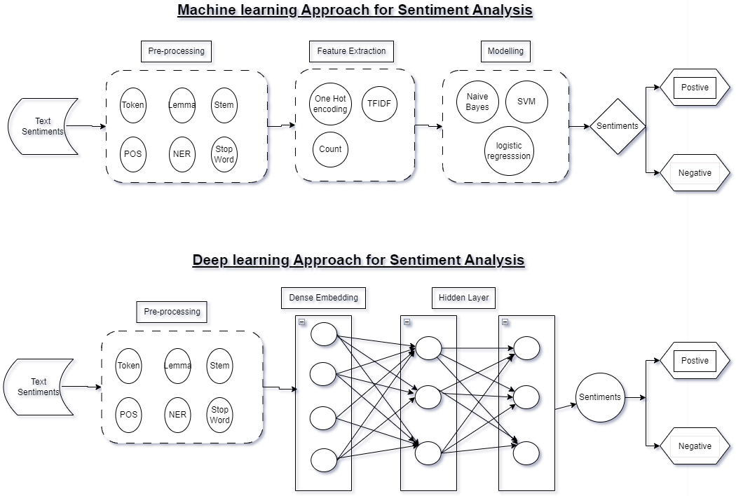

Figure A.1: Sentiment Analysis

* + 1. Reinforcement Learning Framework

A Reinforcement Learning (RL) framework (brief architecture is displayed in Figure 2: Unsupervised Learning (Reinforcement Learning)) will be developed to model the decision-making process in stock trading based on the sentiment analysis results. RL algorithms combined with Deep Neural network (LSTM) in Figure 3: LSTM Network (to be used in conjunction with RL architecture in Figure 2) will be employed to learn optimal trading strategies by interacting with the market environment and maximizing a defined reward function.

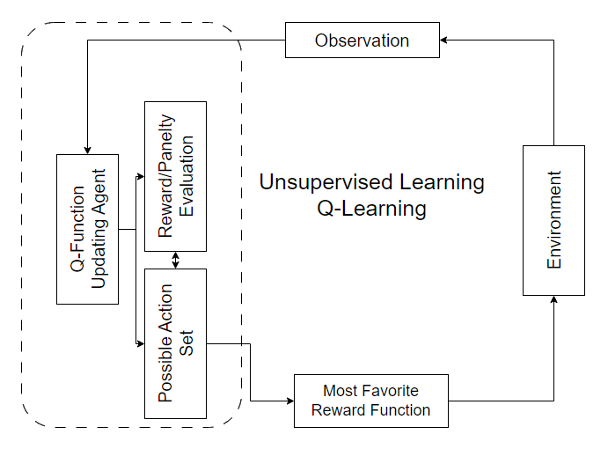

Figure A.2: Unsupervised Learning (Reinforcement Learning)

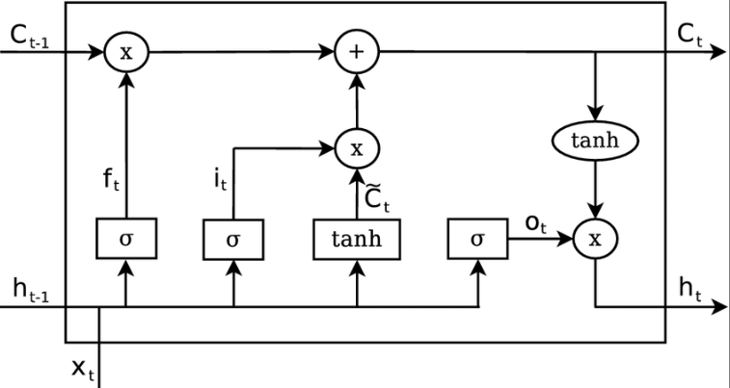

Figure A.3: LSTM Network (in conjunction with RL architecture in Figure 2)

* + 1. Model Evaluation

For evaluating the proposed NLP and DRL model combining historical market data and texts to generate the insight, it is important to capture the sentiment of the text correctly and corelate it with the historic price data. In order to check the effectiveness of such a model, several performance metrics such as Accuracy, Precision, Recall (Sensitivity), F1-Score can be considered.

Since the aim of this study is also to improve the trading decision and reduce the possible losses and hence some of the financial metrics may also be used to check the performance of the prediction. Some of the such business metrics are listed below with a brief explanation.

* Cumulative Returns: Cumulative returns measure the total returns generated by the investment strategy over a specified period.
* Sharpe Ratio: The Sharpe ratio measures the risk-adjusted return of an investment strategy.

These metrics shall provide a comprehensive evaluation of the model's predictive power, profitability, and risk-adjusted performance.

The findings of the model will be interpreted to identify patterns and correlations between sentiment and price moves. Visualizations, statistical analysis, and qualitative assessments will be used to gain insights into the impact of sentiment on stock prices and financial market dynamics. Various graph depicting superimposition of real price move v/s predicted price moves shall provide a better mean of deciphering the results and make a profitable strategy.

* + 1. Limitations

Potential limitations of the research methodology include constraints on data availability, the inherent uncertainty and volatility of financial markets, and simplifying assumptions made in the model.

###### Expected Outcome

The proposed study aims to leverage NLP to extract the sentiment from the tweets relevant to the market movement. The application of LSTM with reinforcement learning will enable identification of the patterns and corelation within stock data enhancing the predictive capabilities of the model. The expected outcome of this study is to assist in developing an investment decision making system/signal for stock market by amalgamating state-of-the-art techniques from DRL and SA, thereby providing the individual investor, traders and market practitioners with more accurate and reliable tool for making informed decision in the dynamic market condition.

###### Required Resources

* 1. 1. Hardware Resources

Processor: Intel(R) Core (TM) i5-9300H CPU @ 2.40GHz (or equivalent)

RAM: 8GB

Graphics: Based on the requirements an external GPU can be used

Storage: SSD preferred for faster data access

OS: Windows 10, macOS, or Linux

* + 1. Software and Tools

Programming Language: Python 3.7 as it has a support for most of the latest ml algo

Libraries and Framework: TensorFlow, Pytorch, Keras

Data Visualization Tools: Matplotlib, Tableau

* + 1. Textual Data Processing Tools

Preprocessing textual data: NLTK (Natural Language Toolkit), Spacy

Web Scrapping: Beautiful Soup

Text processing and analysis: spacy

* + 1. IDE – interactive development environment

Jupyter Notebook IDE (based on requirements free GPU resources can be used)

VS-Code

###### Research Plan

Research project plan from Dec-2023 to May-2024 has been listed Figure 4: Research Project Plan. This will be further granularized as the program proceeds. It is using a scaling of 3 days so a plan duration of 6 means ~18 to ~19 days of effort.

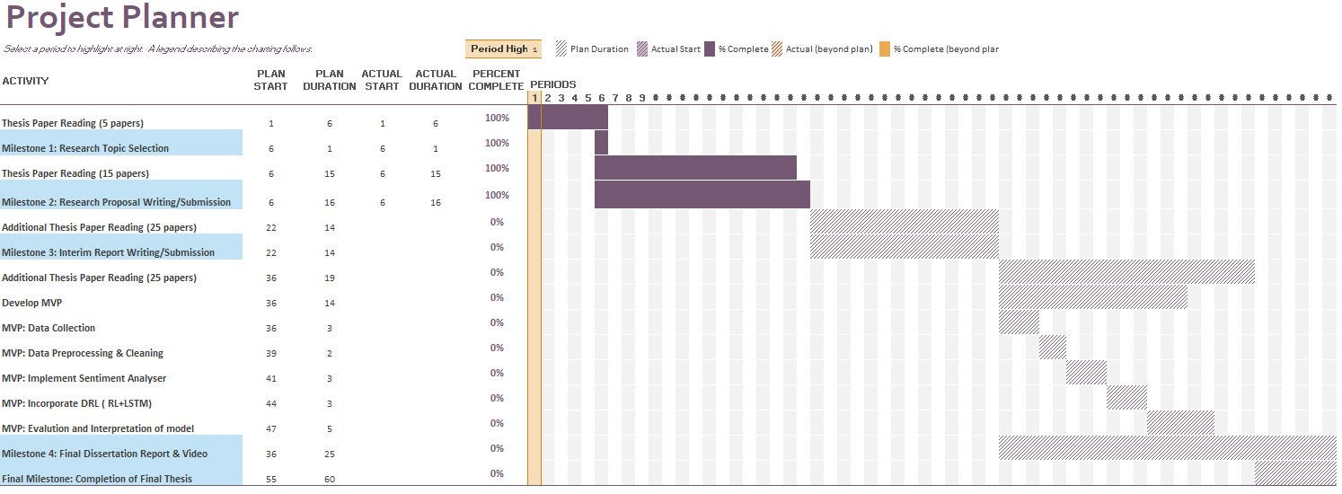

Figure A.4: Research Project Plan

###### Risk and Contingency Plan

Table A.3: Risk and Contingency Plan

|  |  |  |
| --- | --- | --- |
| **S#** | **Possible Risk** | **Contingency Plan** |
| **1** | Impact on the Research plan timelines due to some professional commitments or responsibilities. | It is possible and at times it is unavoidable however research plan proposed above provisions some buffer. |
| **2** | Quality of the thesis is not up to the mark. | Regular catchup with Thesis Supervisor can help get the timely feedback on the improvement of the quality of thesis. |
| **3** | Given the outcome of the thesis is quite challenging i.e. combine SA with LSTM+RL, it is possible that it does not produce the expected outcome. | Meeting milestone as listed in the Research plan on time, putting a system of checks and balances, regular catchup with Thesis Supervisor should keep the Research on track and achieve the expected outcome. |
| **4** | Computational Resource challenges – training a large set of data using LSTM and RL may require significant computational resource and time. | Optimizing the model by hyperparameter tuning, train at small dataset instead of large datasets, consider using the cloud platform could be some of those options that can help mitigate this risk |